1. 1.Last course we saw how we can use model data to increase rewards and value functions
2. But not always its possible to build model and use it
3. To solve this we have sample based learning methods,where we learn by trial and error (expeience)and use only data
4. 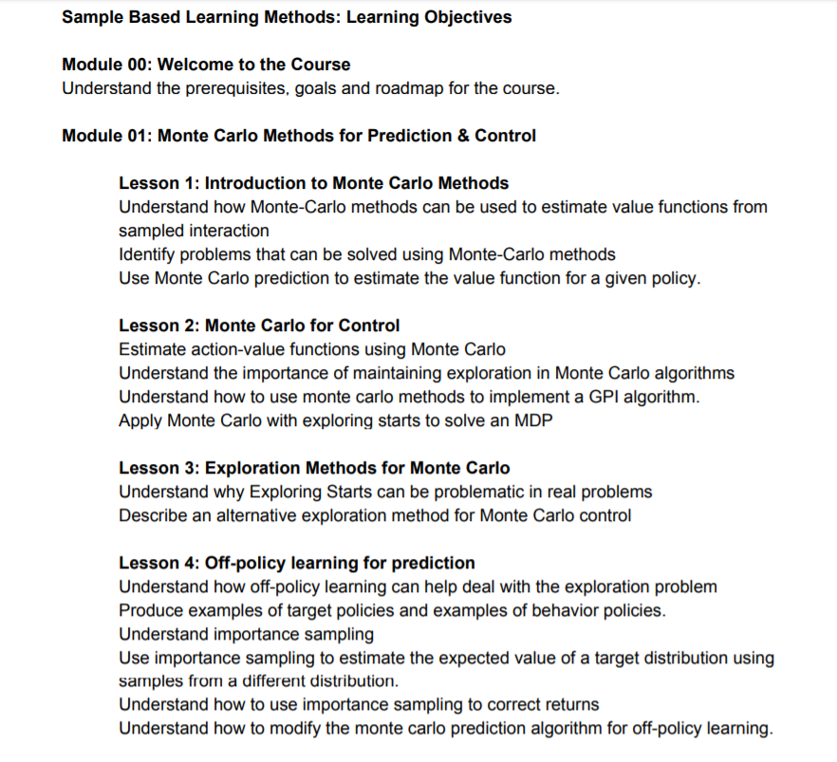
5. 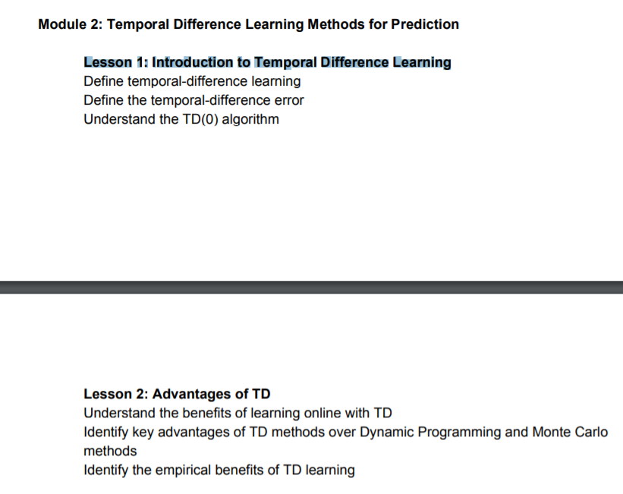.
6. 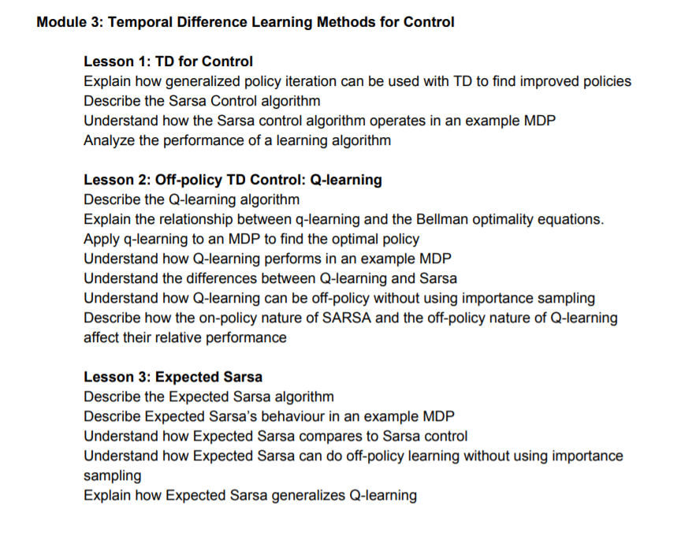
7. 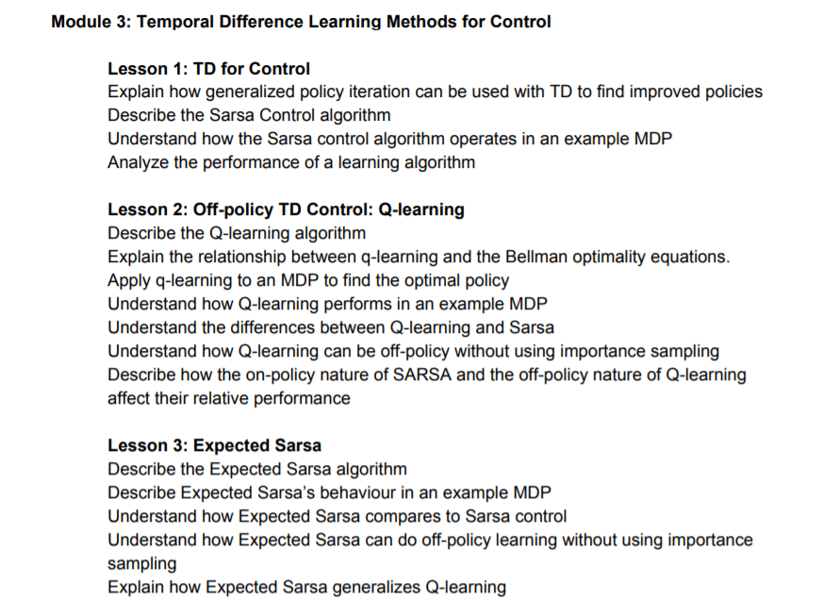
8. 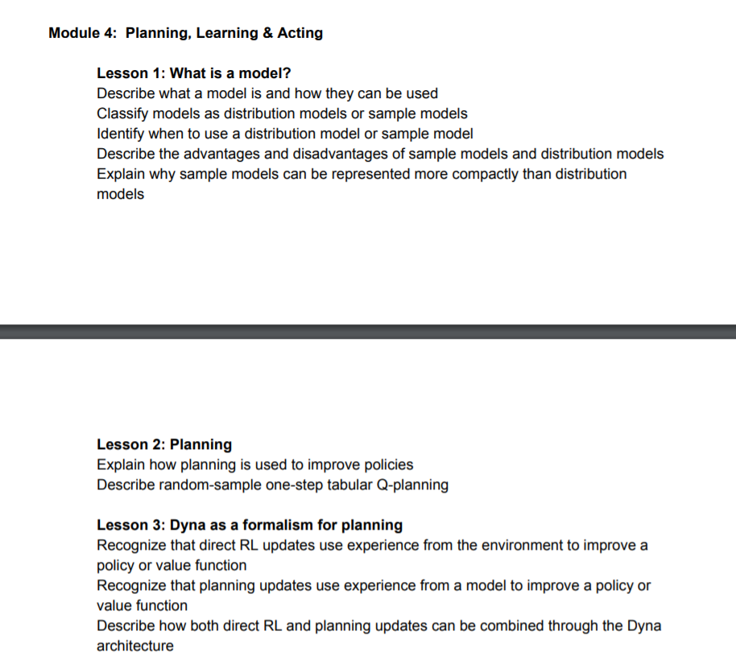
9. 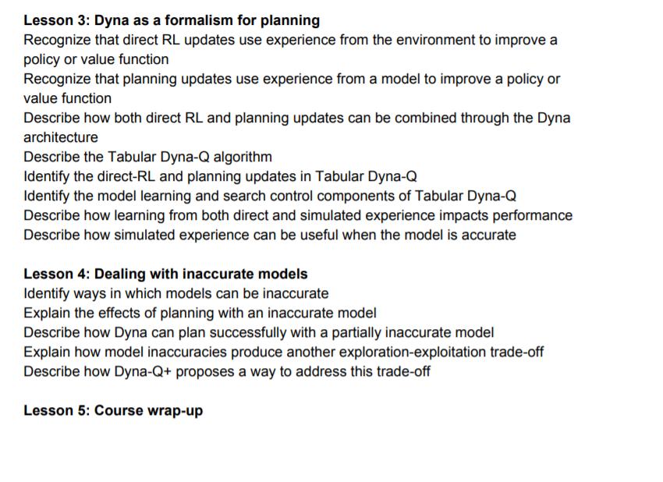
10. 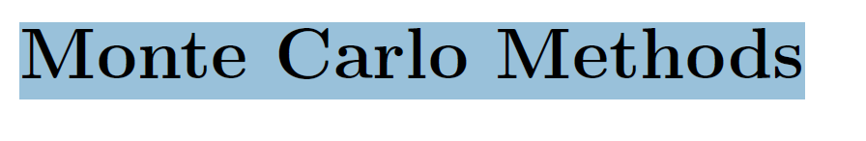
11. .
12. 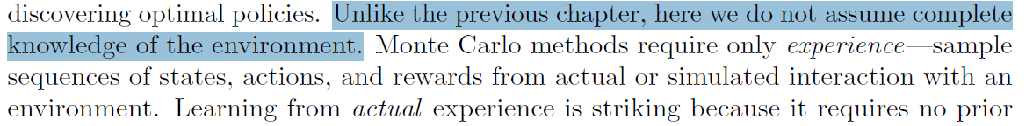
13. .To ensure that well-defined returns are available, here we define Monte Carlo methods only for episodic tasks. That is, we assume experience is divided into episodes, and that all episodes eventually terminate no matter what actions are
14. Only on the completion of an episode are value estimates and policies changed.
15. In Monte carlo ,agent will estimate value-function from experiences
16. 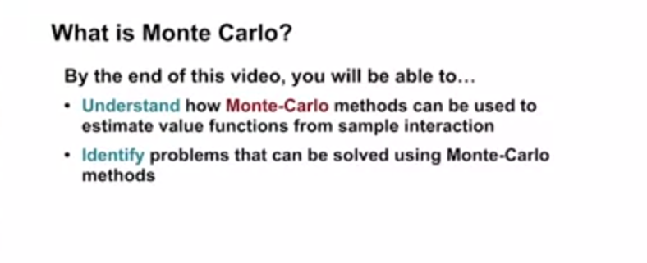
17. 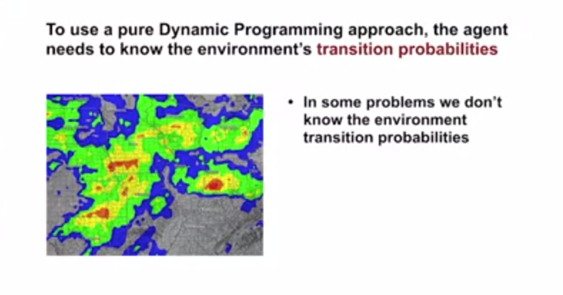
18. .
19. 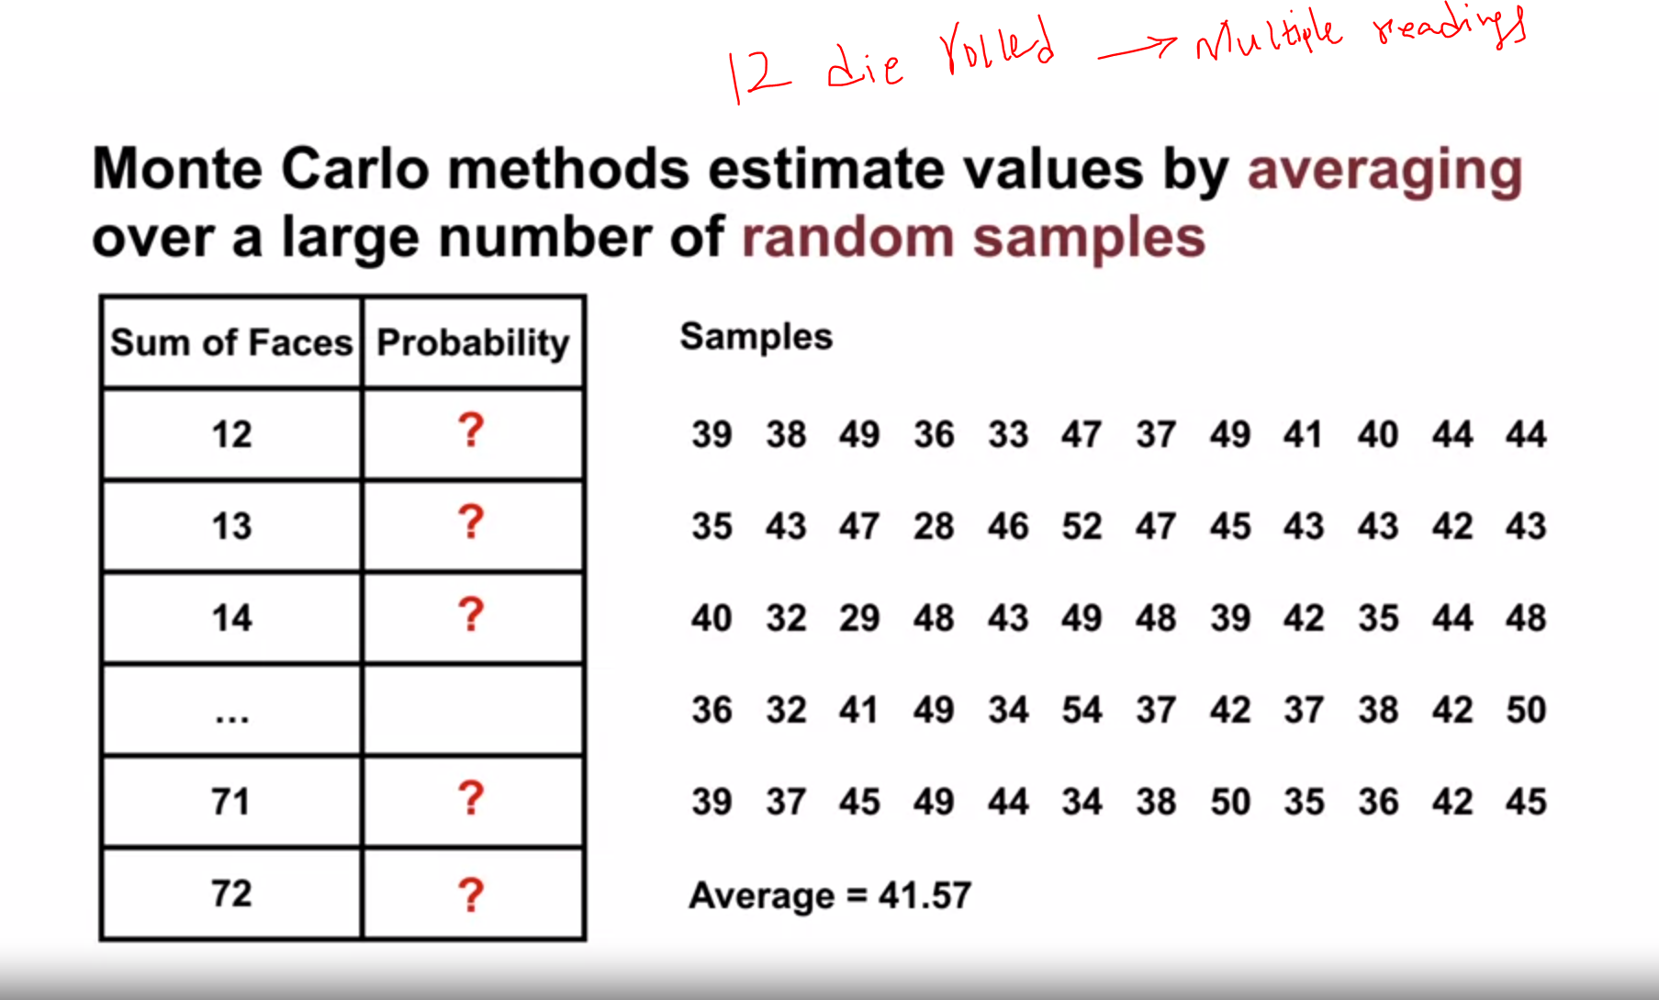
20. .
21. 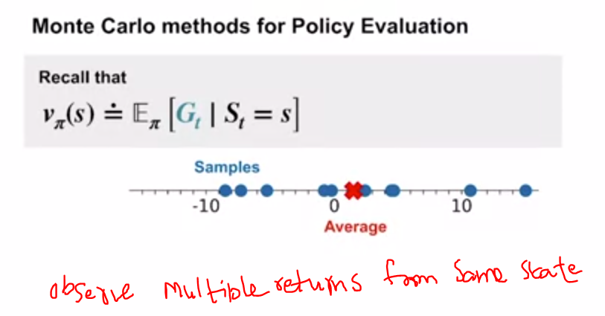
22. .
23. 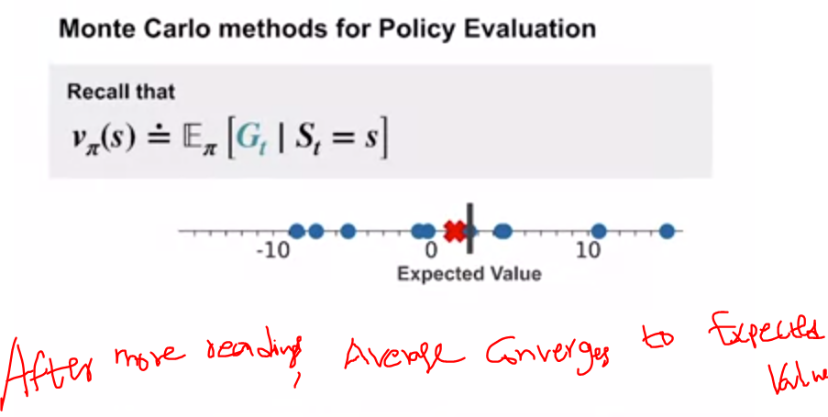
24. .
25. 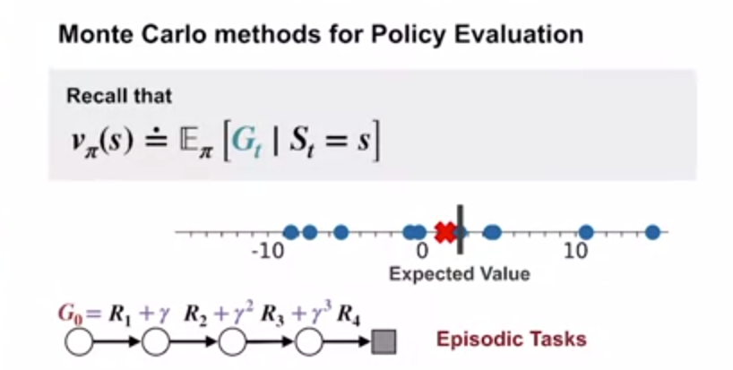
26. .
27. 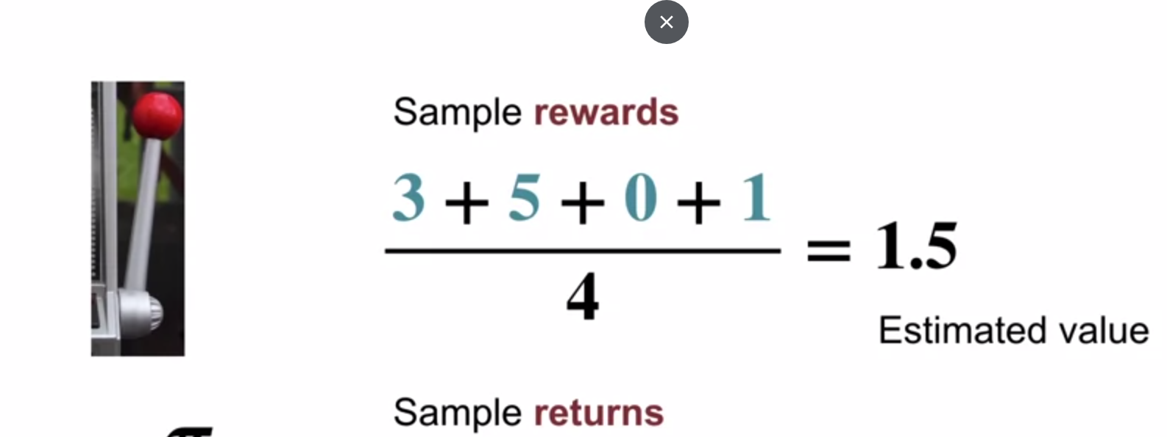
28. .
29. Black Jack
30. 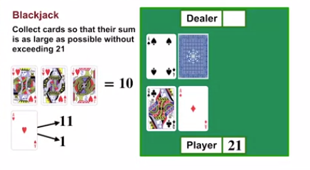
31. If player got <21 ,he can keep asking for more cards or he can stop and ask dealer to get cards
32. Also dealer only hits if his sum of cards <17
33. 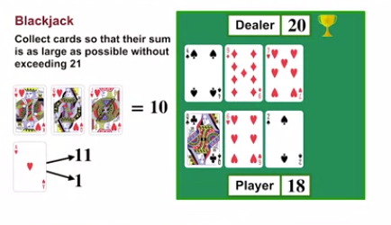
34. Dealer won as he is closer to 21
35. 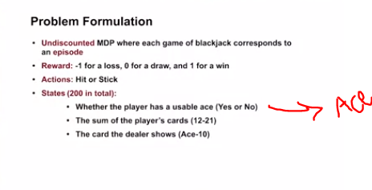
36. 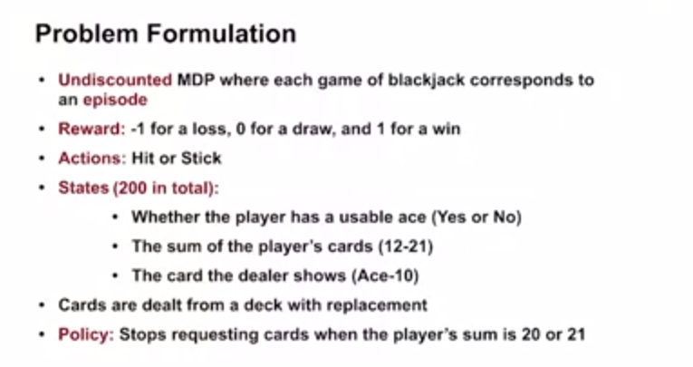
37. . 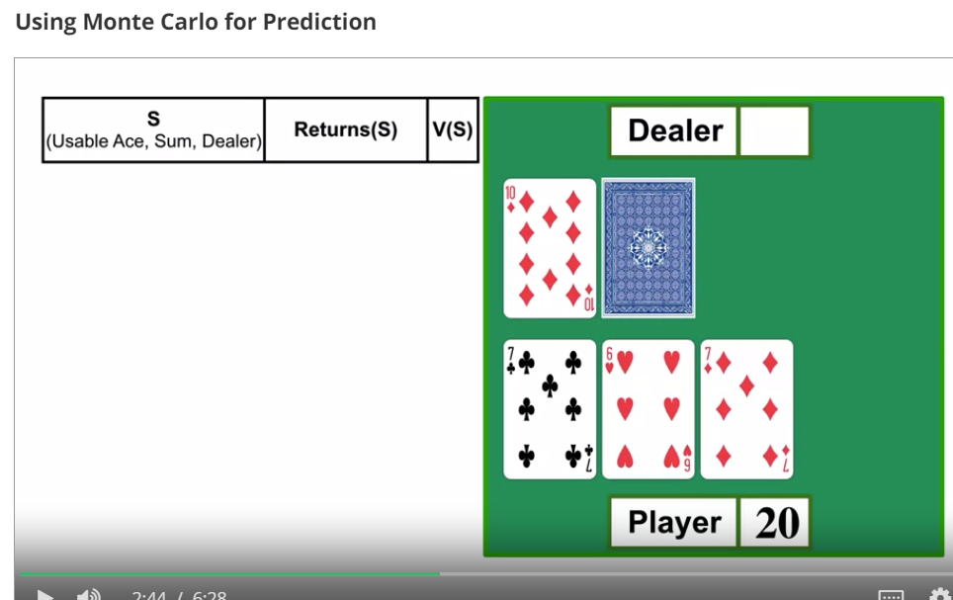
38. Agent sticks to 20 and gives turn to dealers
39. 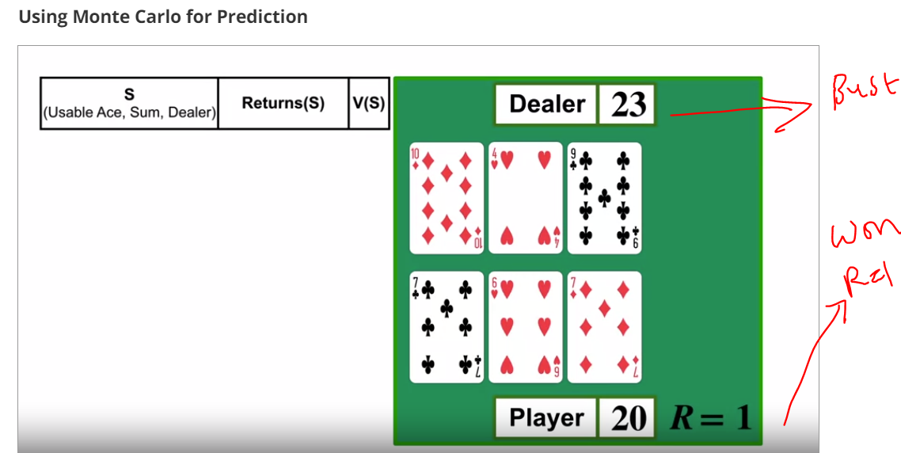
40. Now lets go back or unfold backwards and record states
41. . lets looks at states
42. 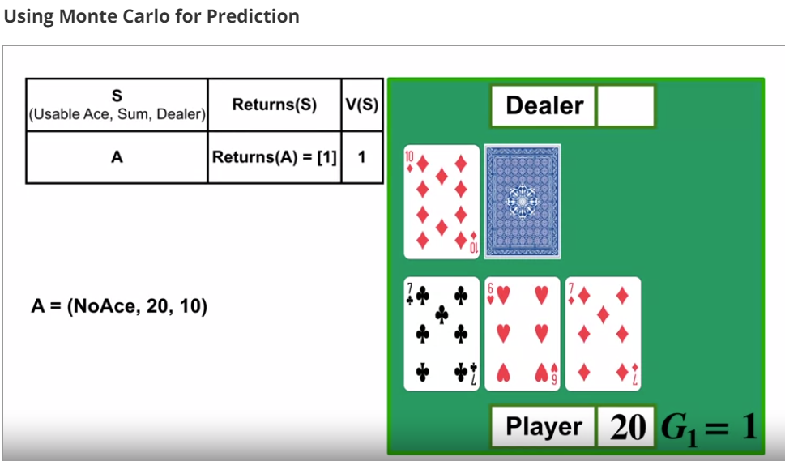
43. State-A = average of list
44. . second last state,state-B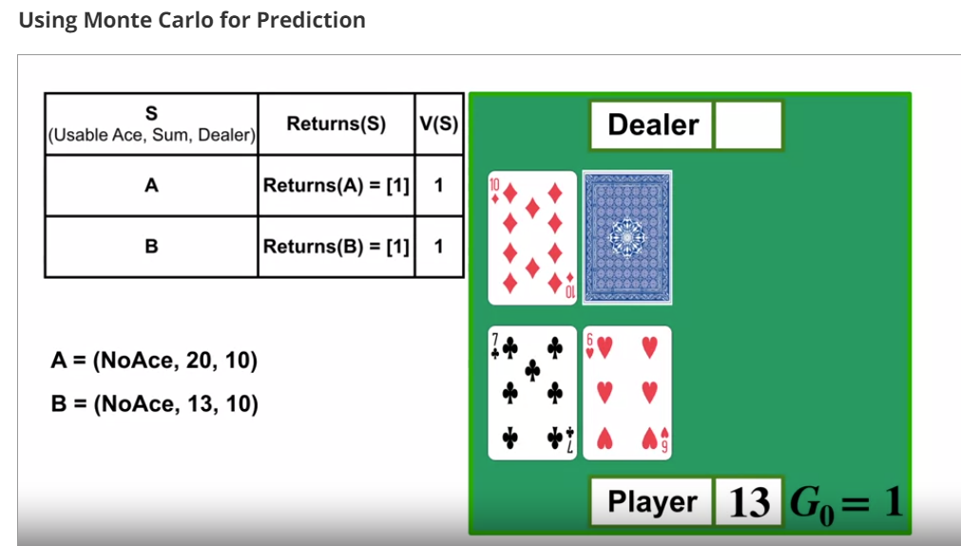
45. +1 to list of returns and state-B =1 which average of list of returns
46. Always value of state A or state B is avergave of returns in list
47. Thus we finished monte carlo updates for 1st episode
48. Now lets say agent ran for many episodes or black jack games
49. 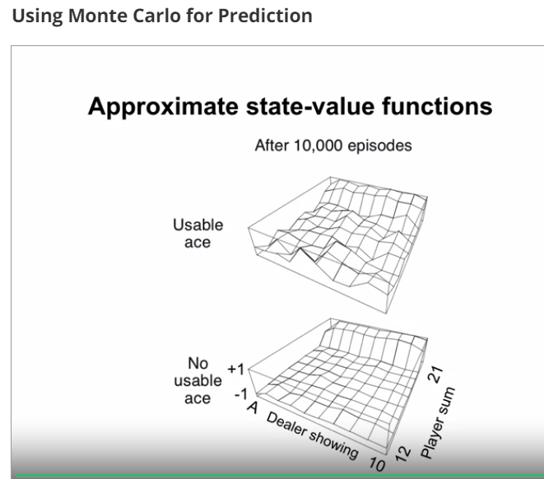
50. .
51. 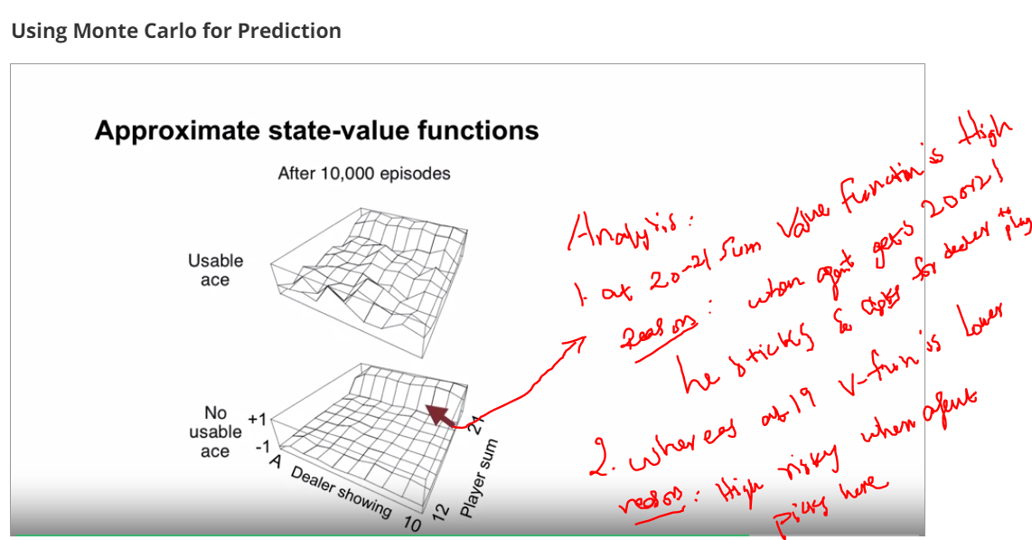
52. 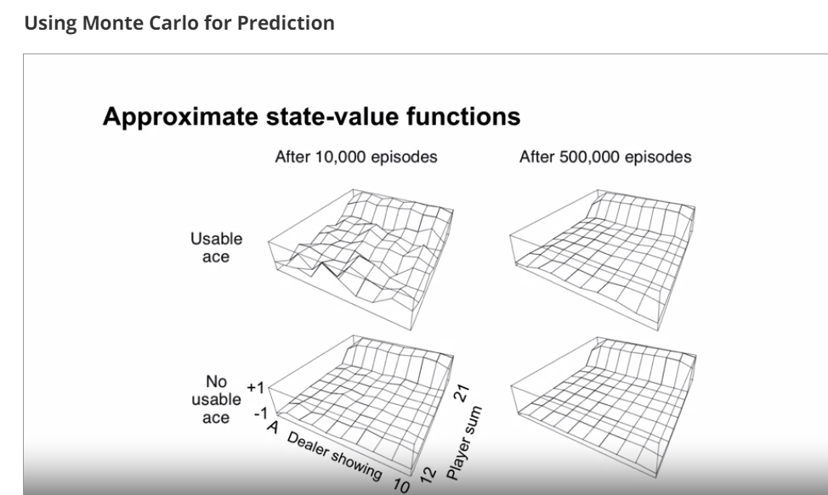
53. .
54. 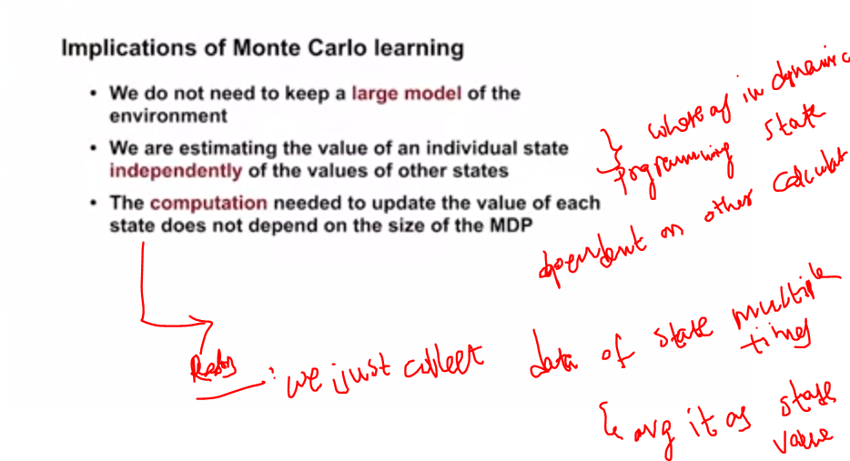
55. 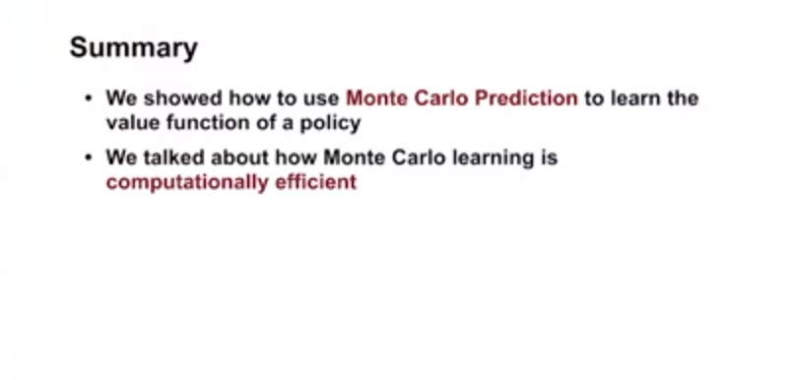
56. Till now we saw state values
57. Let study now action values
58. Why we need action values to estimate ??
59. Sol :to identify a policy
60. 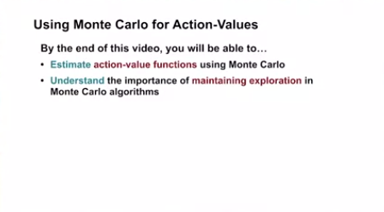
61. Like how we did average of returns in one state.we follow same approach for action values also
62. We collects returns by following a policy froam a state action pair and take avg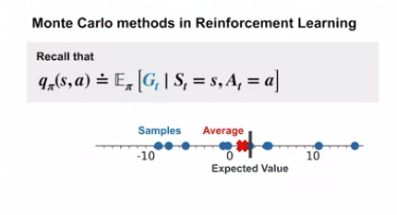
63. . 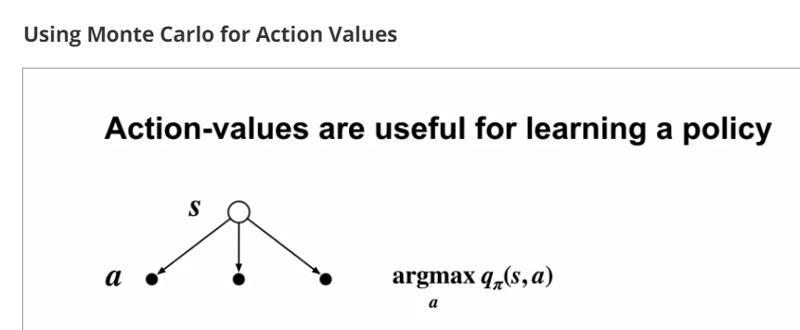
64. 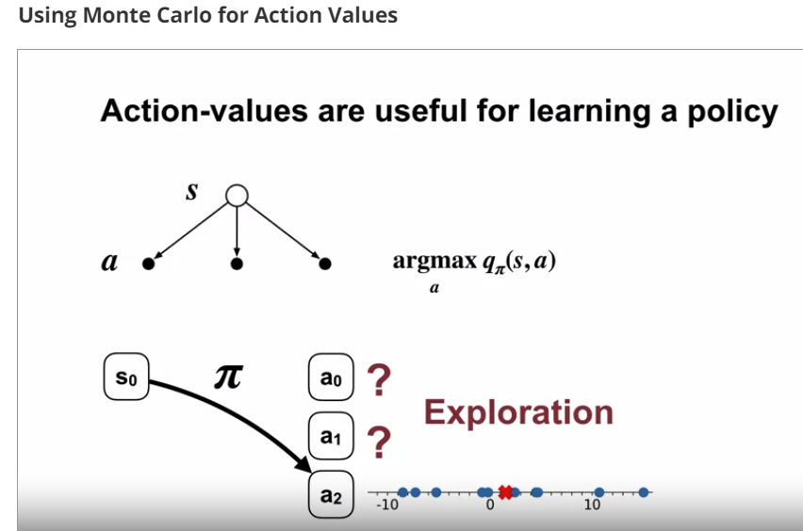
65. Agent must try all actions in that state to fully understand which is best
66. .
67. 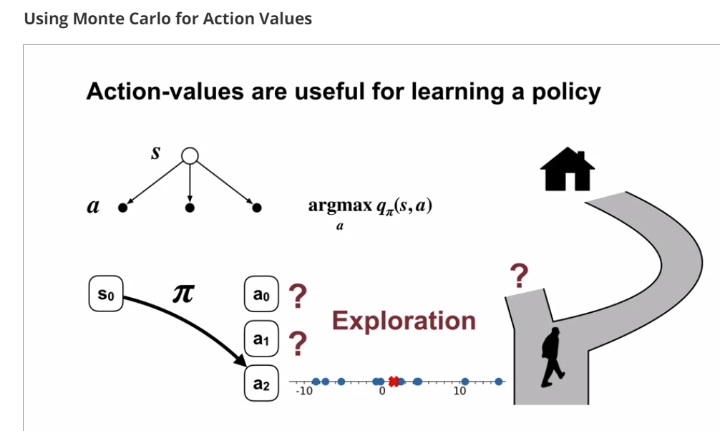
68. . 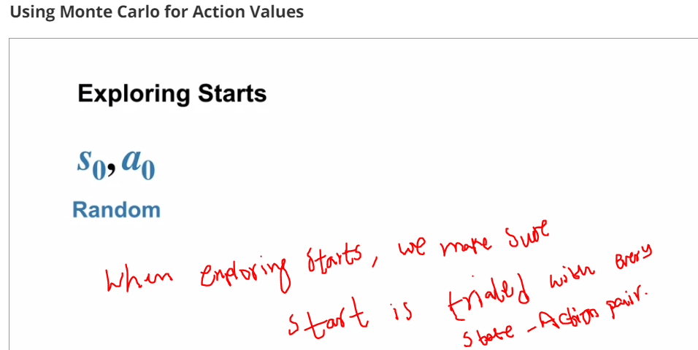
69. .
70. 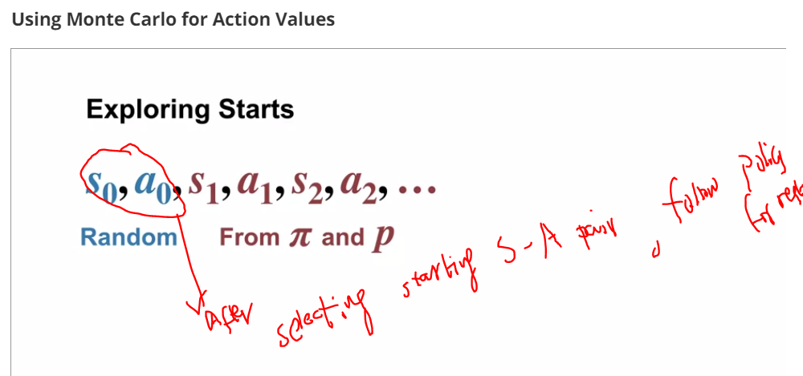
71. .
72. 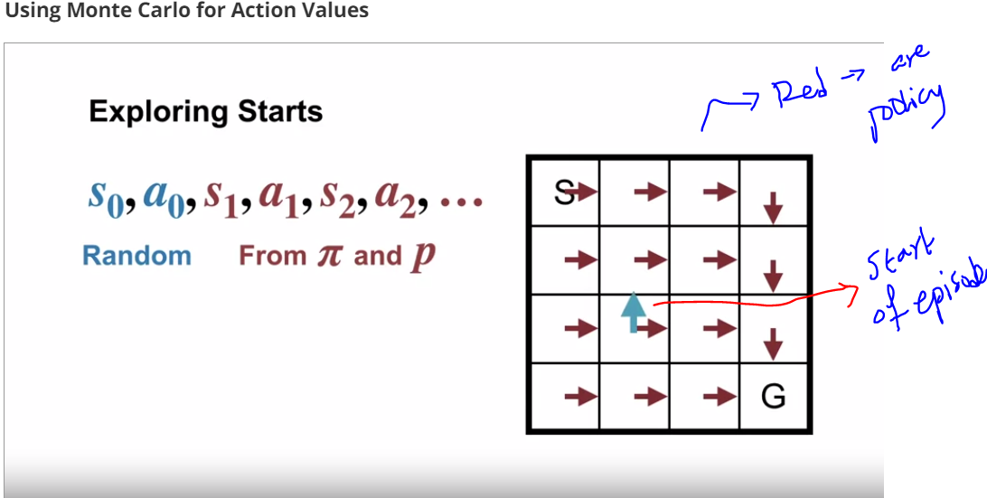
73. .
74. 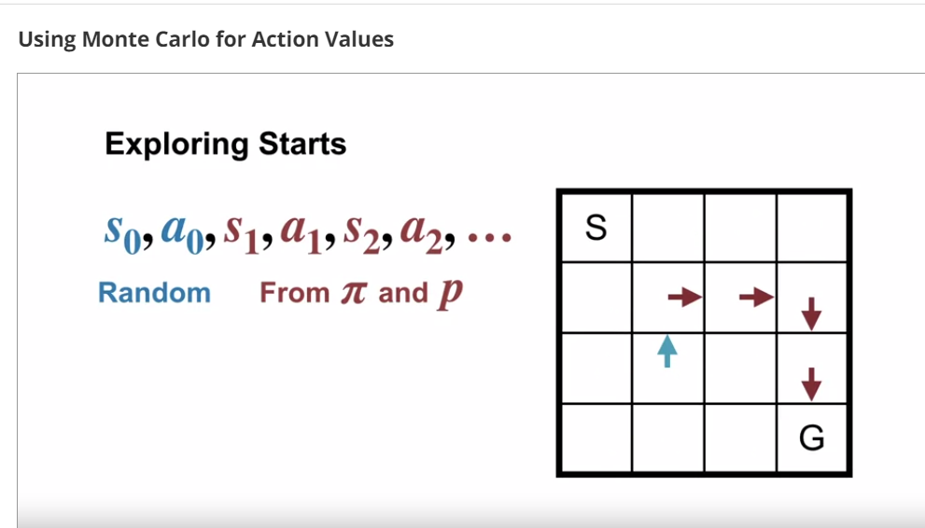
75. .
76. 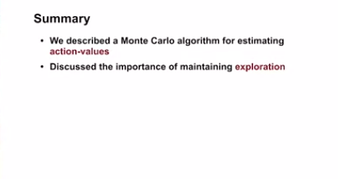
77. .Now that we finished how to estimate action-value ,we now study generalized policy iteration using monte carlo
78. 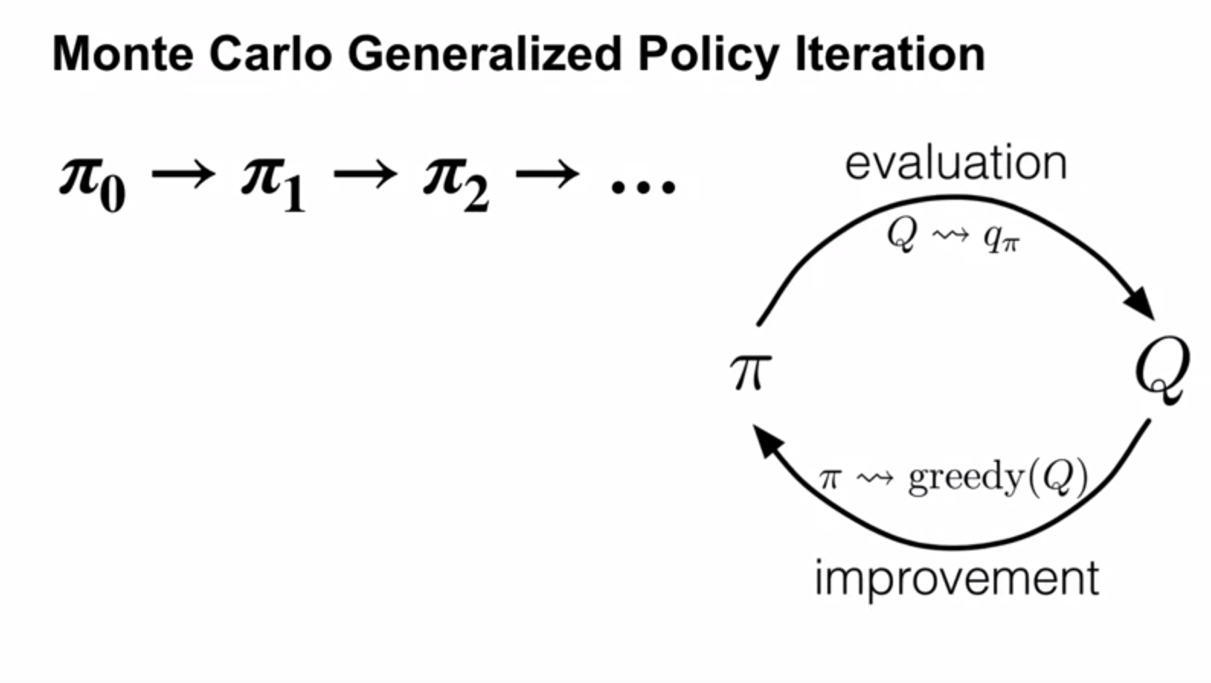
79. GPI involves both evaluation and improvemen
80. .
81. 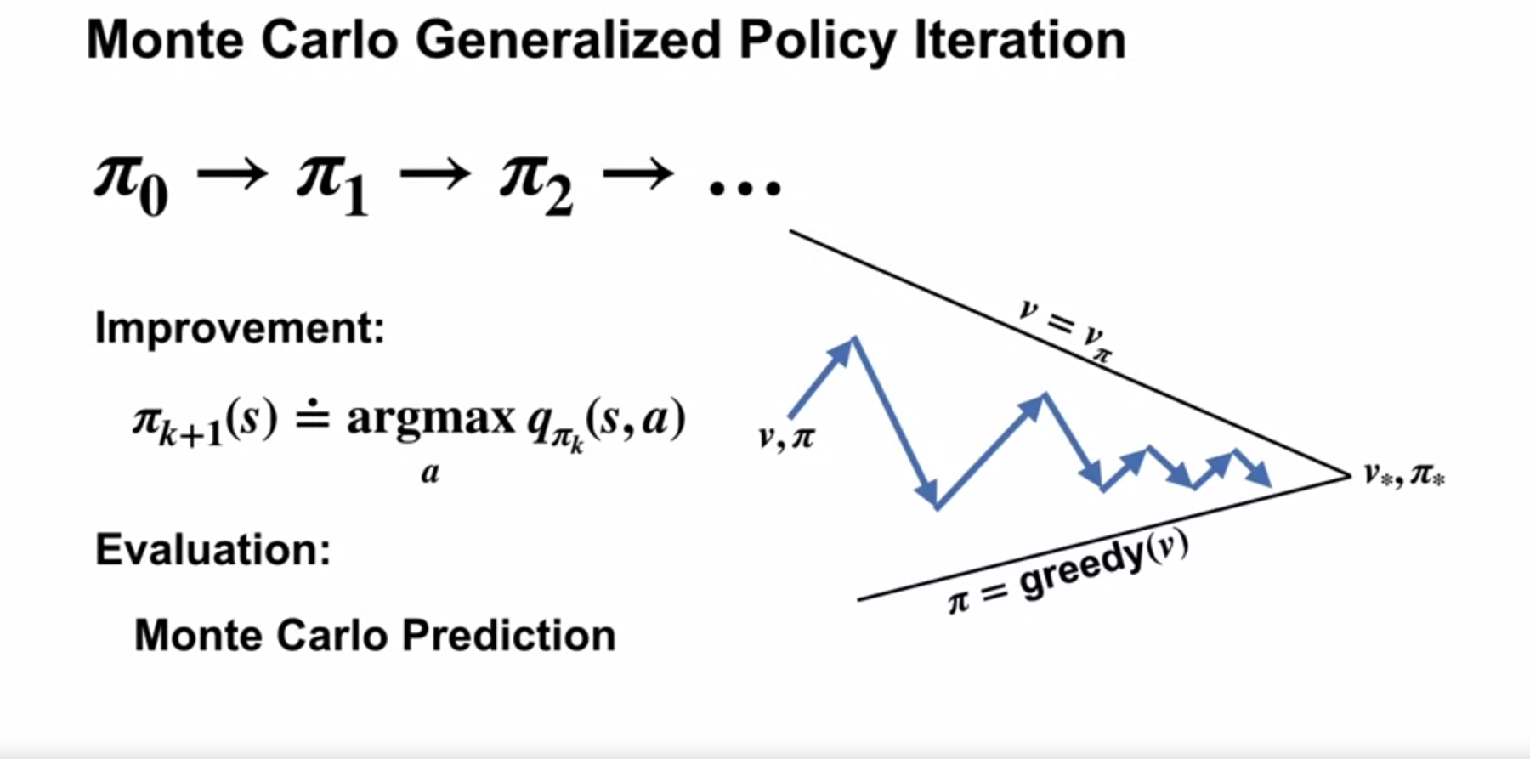
82. .
83. 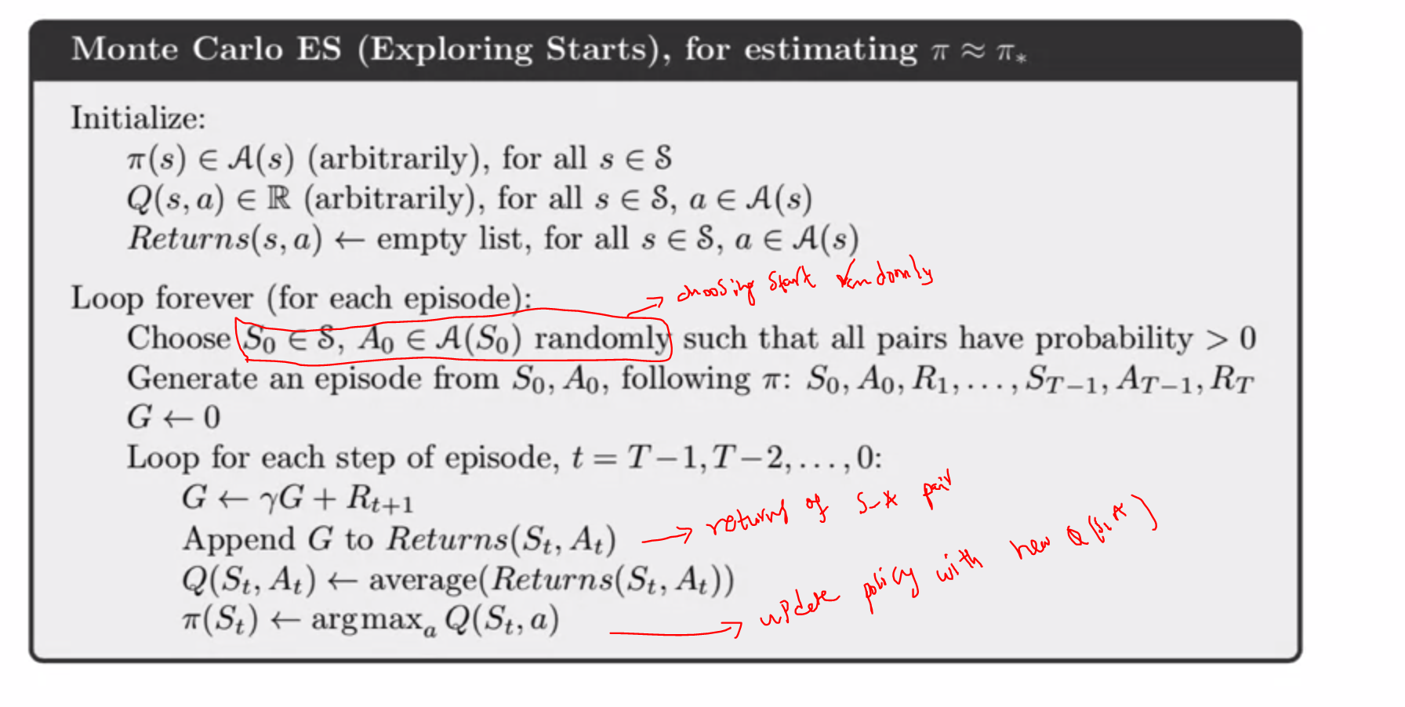
84. .
85. 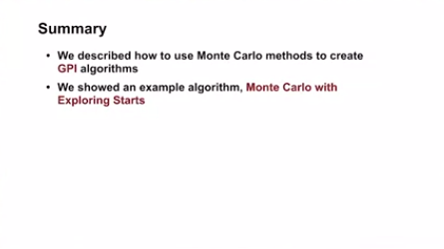
86. 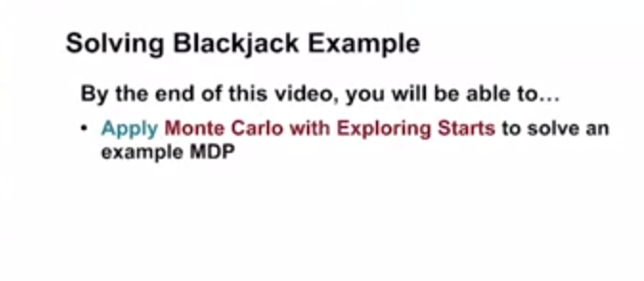
87. Lets learn a policy
88. .
89. 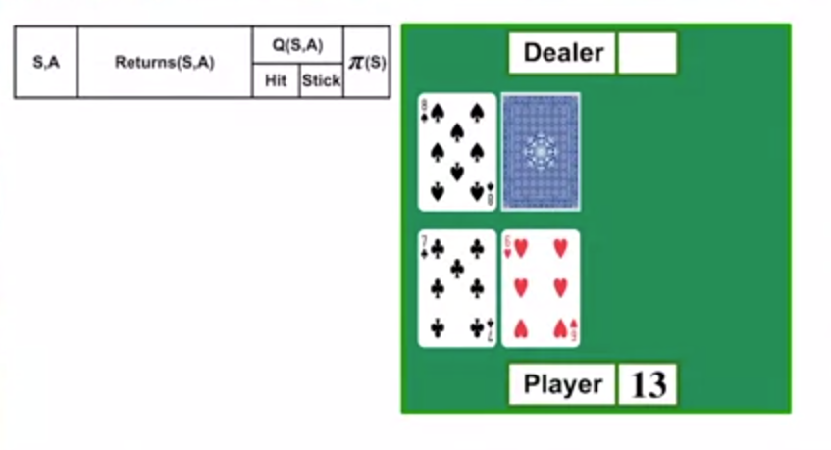
90. .
91. Now agent will select random state – action and start
92. Lets assume initially policy agent sticks if sum=20,21 and hit if sum <20
93. .
94. Step-1:since sum is now 13,agent does action HIT
95. 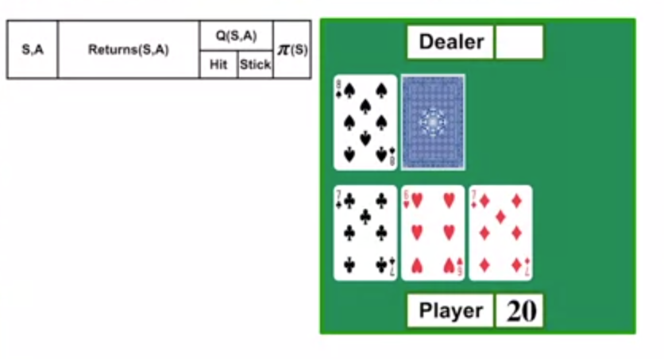
96. Step2:since sum=20 ,agent sticks
97. Step3:now dealer shows card
98. 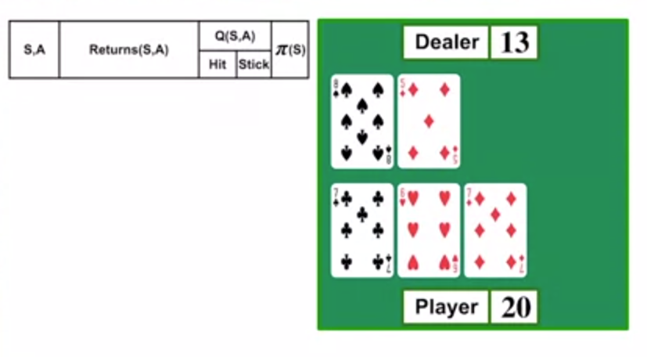
99. Step4:dealer hits
100. 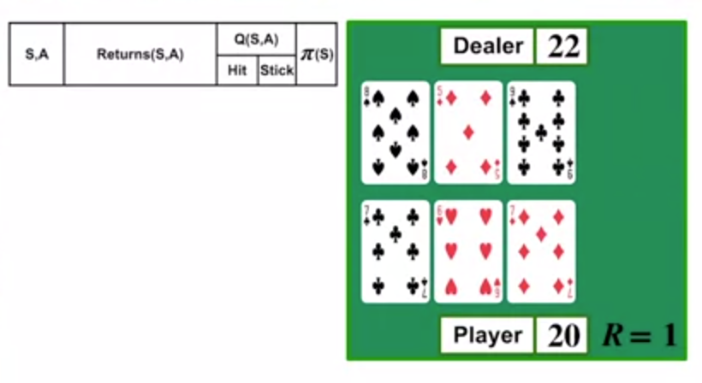
101. Hurray dealer got sum=22
102. So agent wins
103. And get R=1
104. OK
105. Now lets go backward and update table
106. .
107. 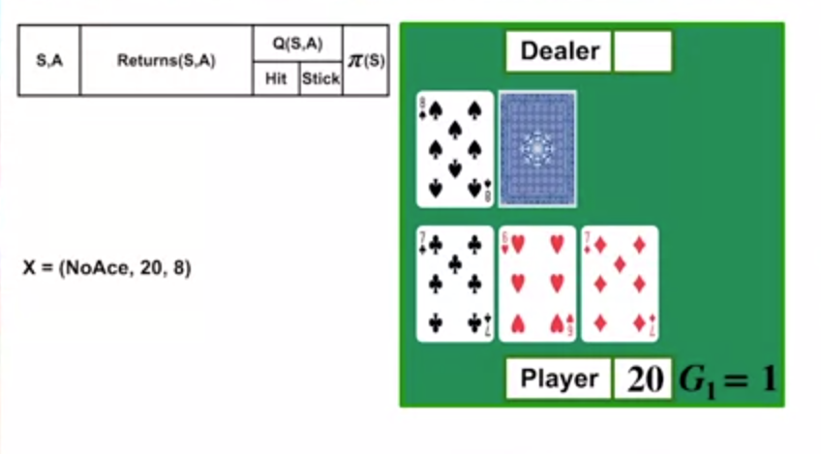
108. 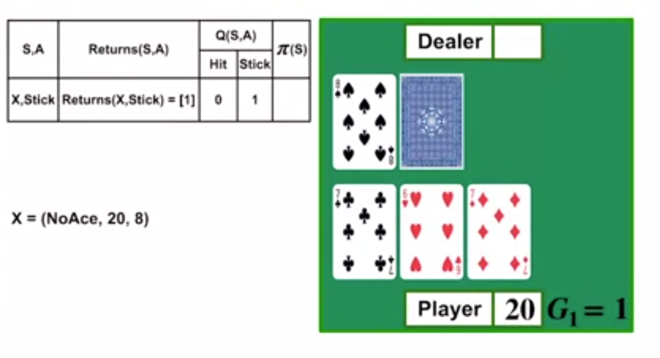
109. .
110. 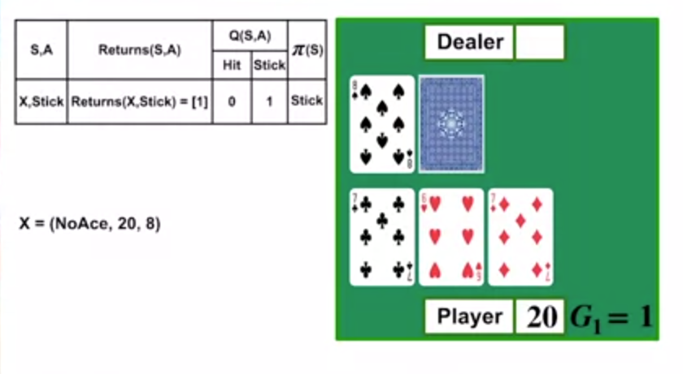
111. .
112. Lets move one more step backwards
113. 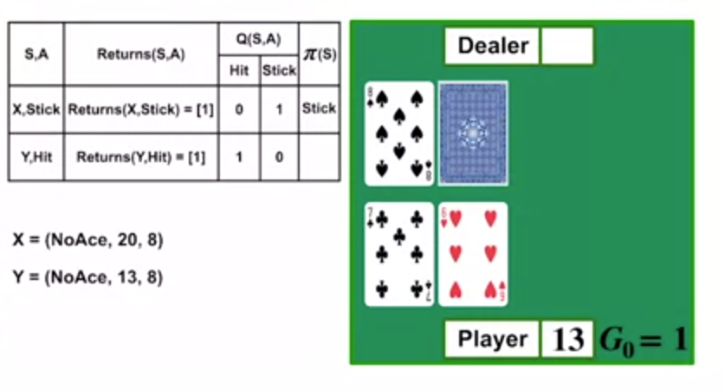
114. .
115. Averga of estimates
116. .
117. 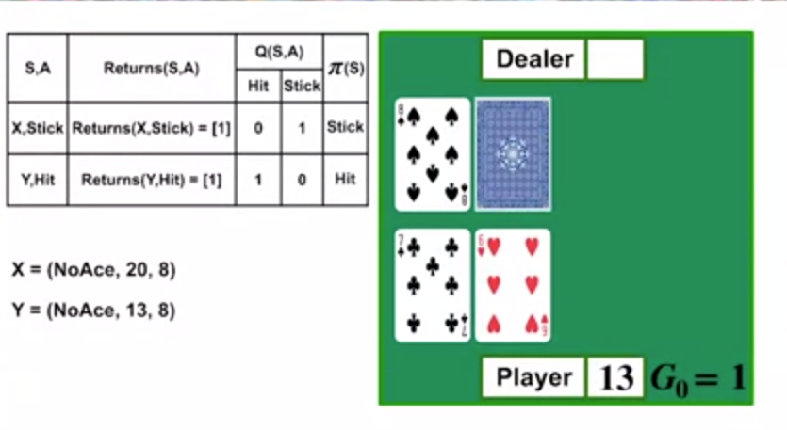
118. .
119. Slowly Action values and policies will approach towards optimal values
120. .
121. 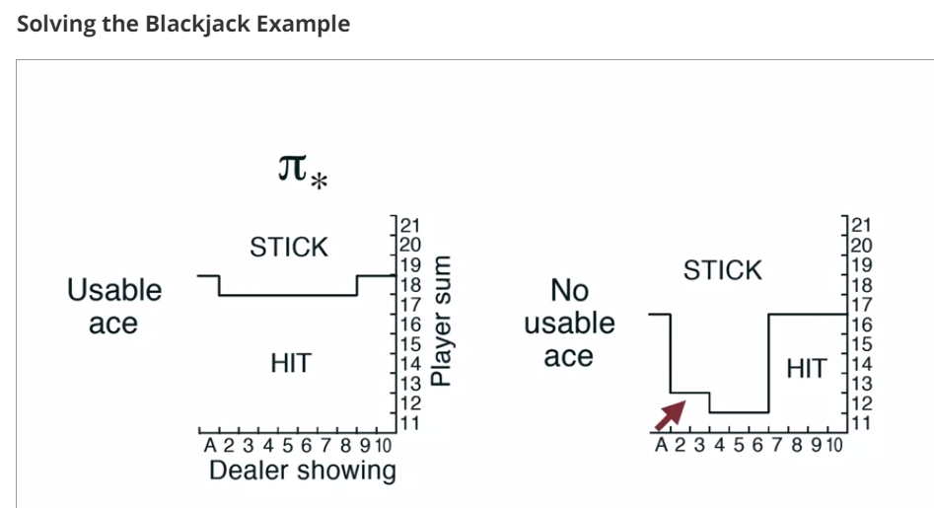
122. .
123. 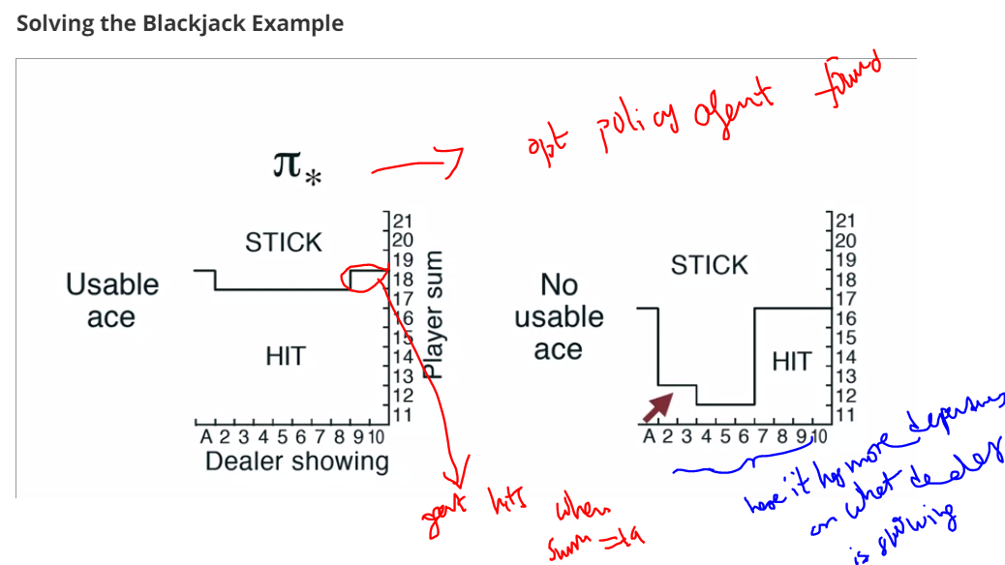
124. .
125. 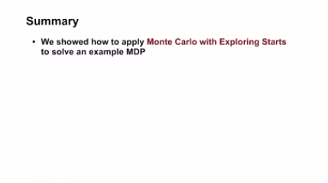
126. .
127. 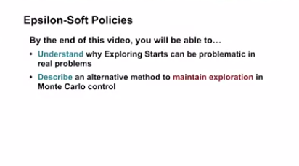
128. .
129. 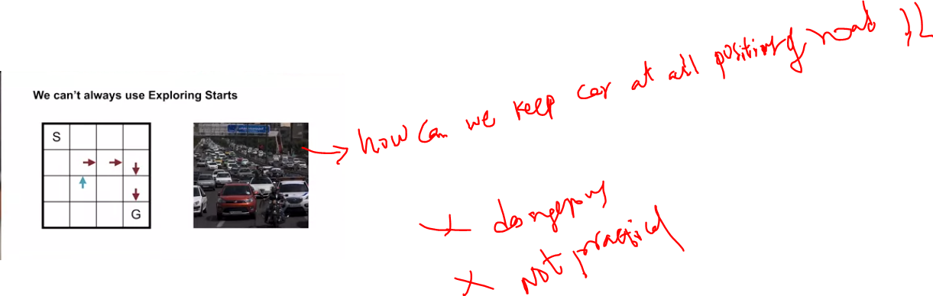
130. .
131. We cant start car at different position of road to fully understand all action values is highly impractical
132. .
133. So how can we learn al action values without exploring different starts ??????????
134. ..
135. Lets go for stochastic policies like epsilon greedy policies in montecarlo too
136. 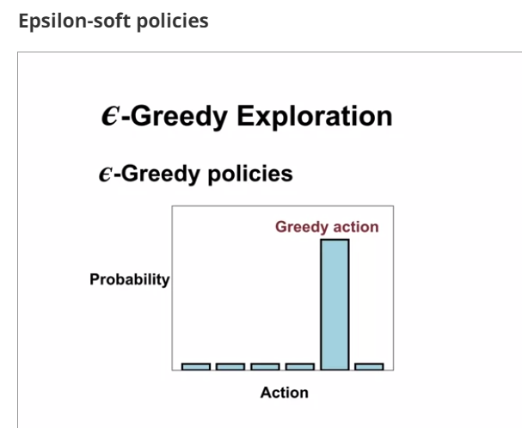
137. .
138. Greedy generally takes max return action and occasionally take random action
139. .
140. 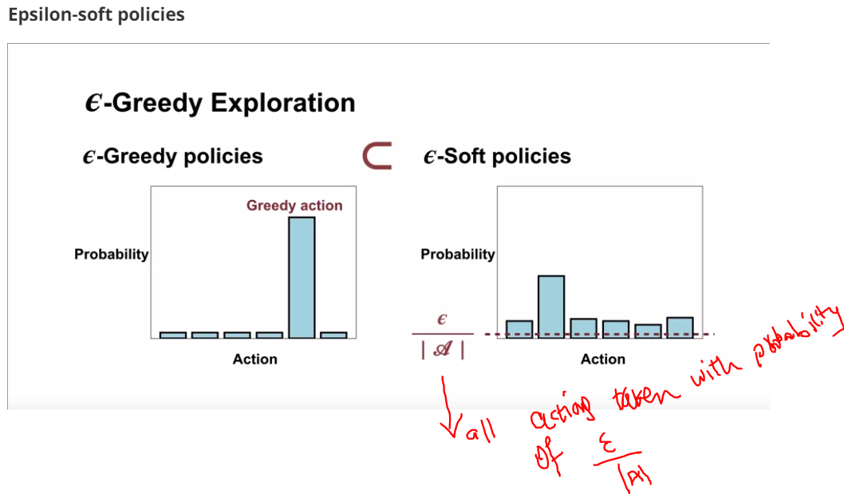
141. .
142. 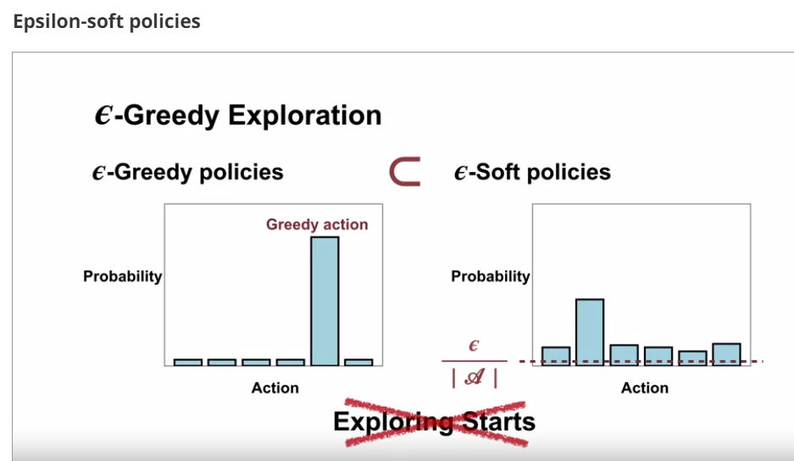
143. .
144. We drop starts exploration in montecarlo with above approaches
145. .
146. SO here in Epsilon -soft ploocies we assign some non-zero probability for each action in every state
147. .
148. Because of this reason Agent can visit all state-action pairs indefinitely
149. .
150. .
151. **Deterministic policy** = policy tells single action in each state to take
152. **Stochastic policy** = policy tells probability value of taken action in each state
153. D
154. .
155. 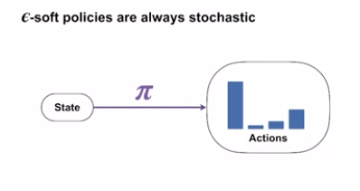
156. .
157. 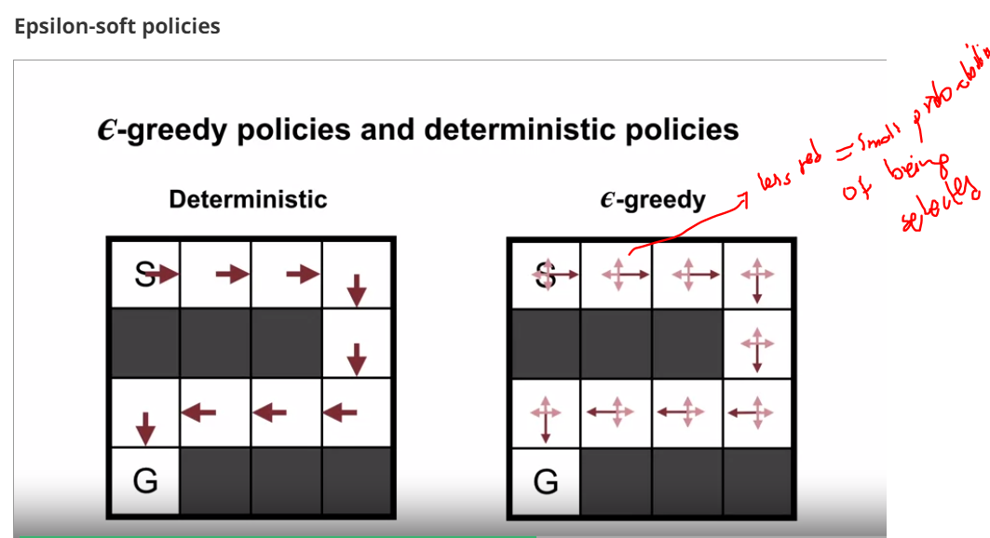
158. .
159. .
160. 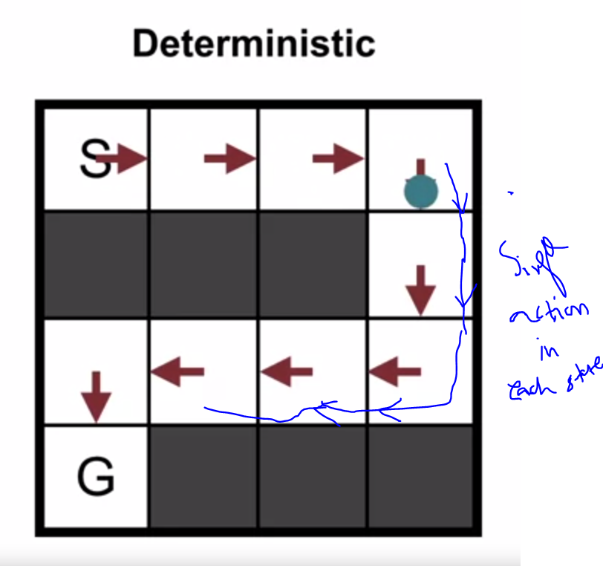
161. .
162. .Now lets see stochastic one
163. .
164. 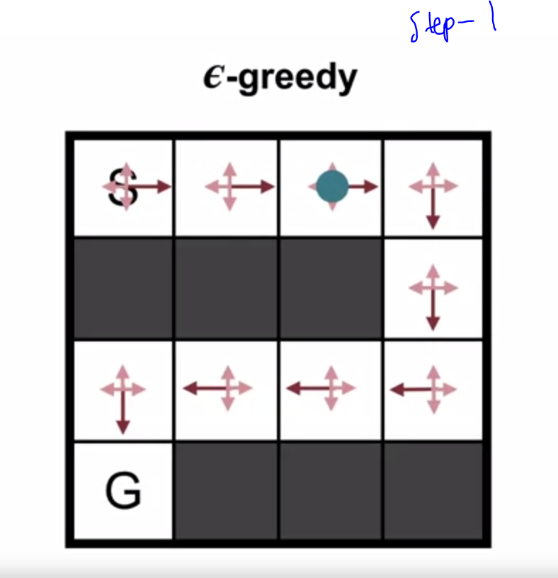
165. .
166. 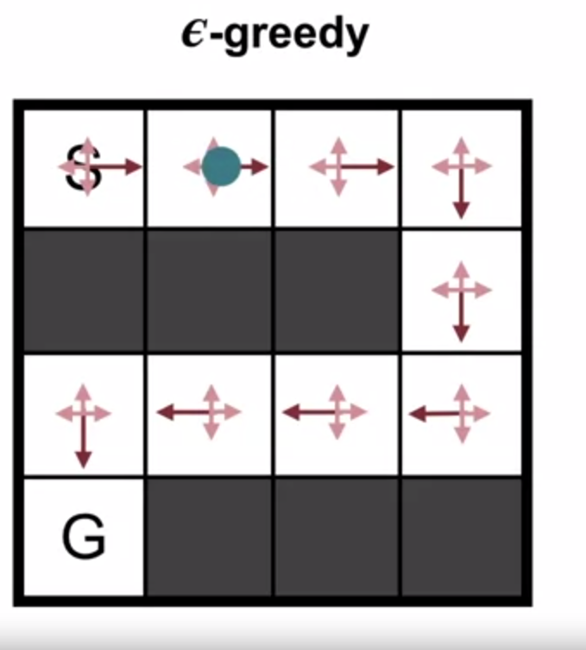
167. .
168. Agent took left action in that state as it has small probability too
169. .
170. 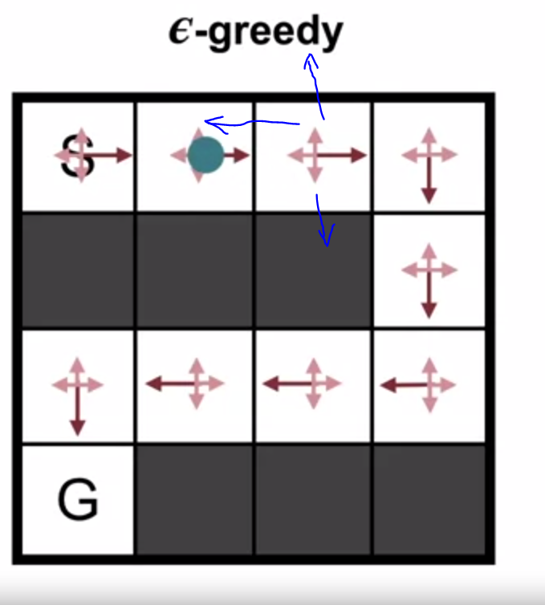
171. .
172. 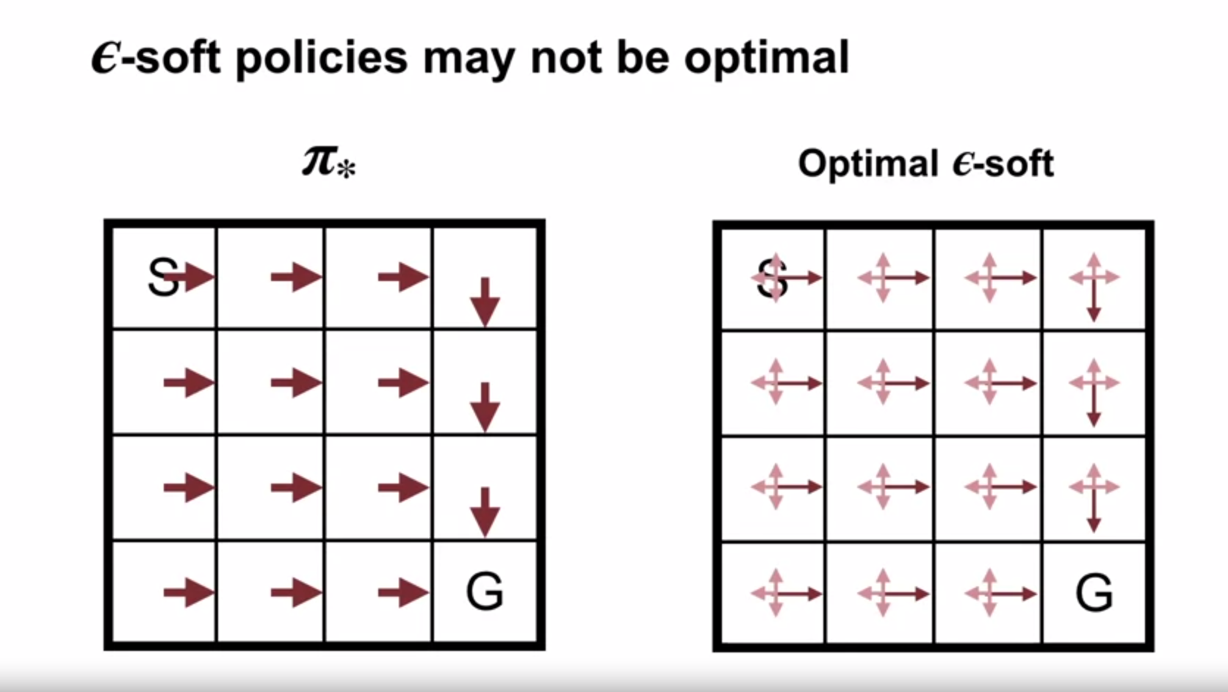
173. .
174. .
175. 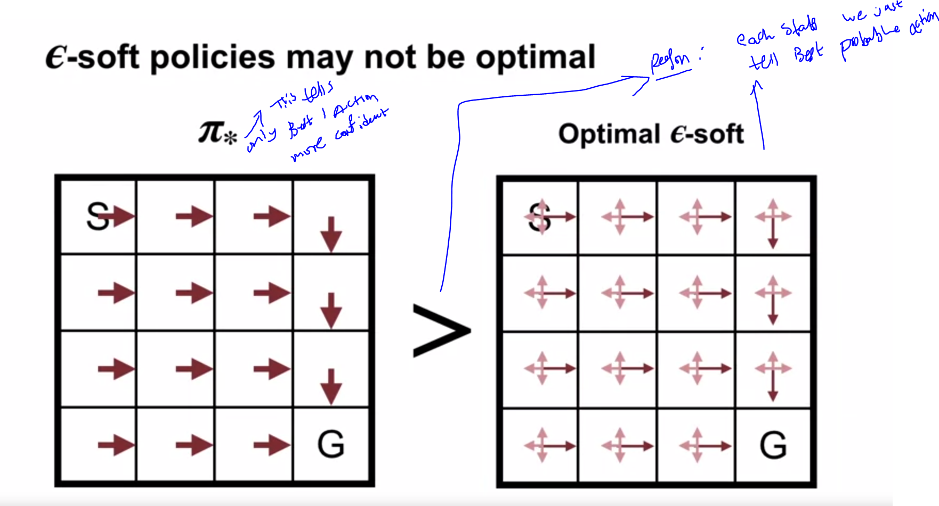
176. .
177. But only advantage of stochastic policy is we can avoid all starts exploration easily
178. .
179. 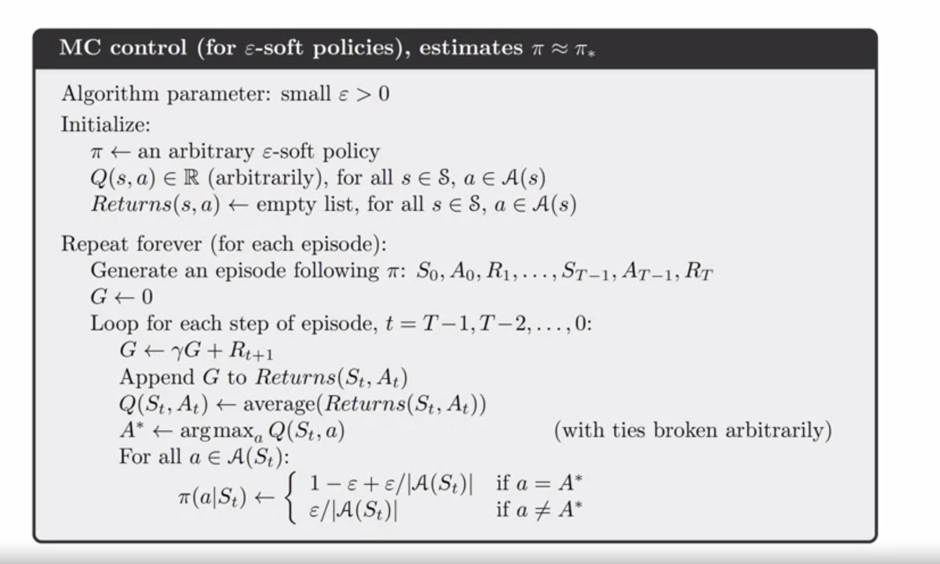
180. .
181. 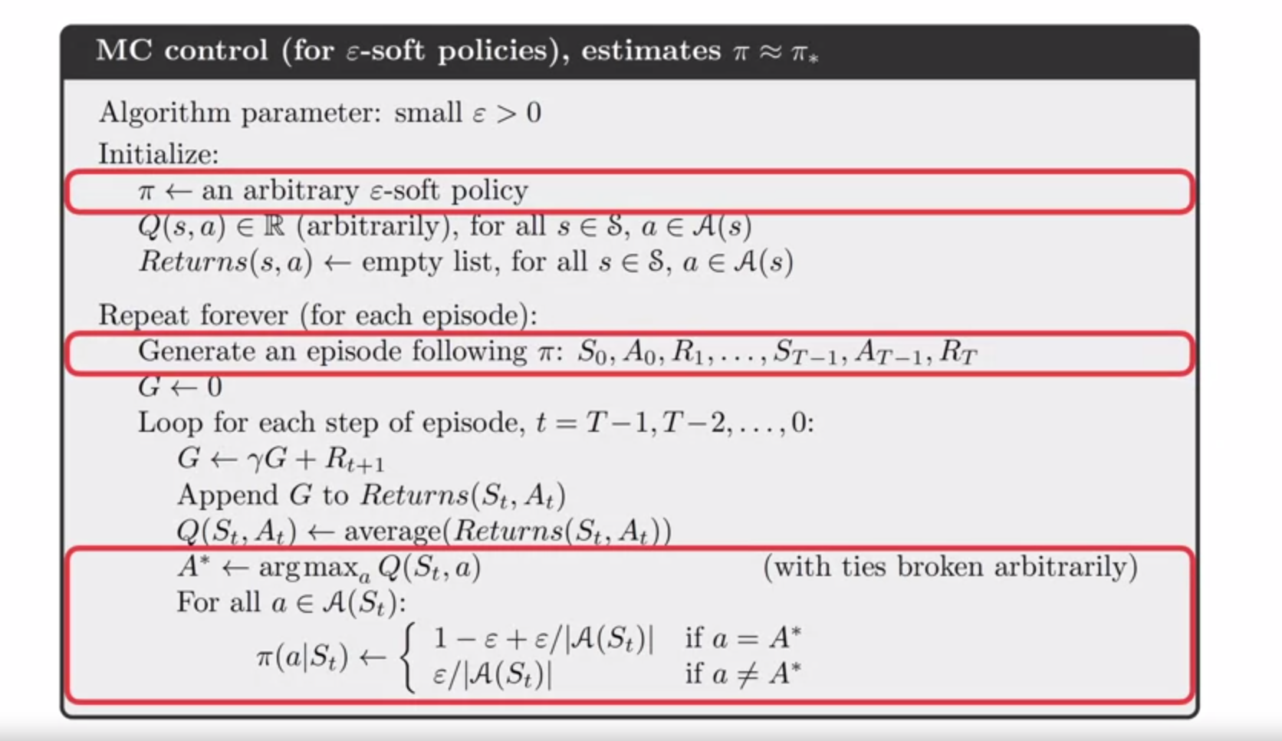
182. .
183. Those are 3 changes comparited to previous algo
184. .
185. 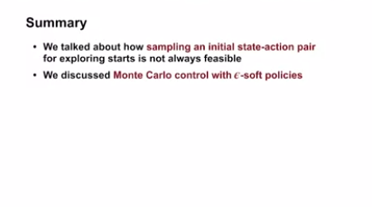
186. .
187. What if exploration is not getting any better rewards snd you simply wasting time
188. We have solution for this
189. OFF-policy
190. 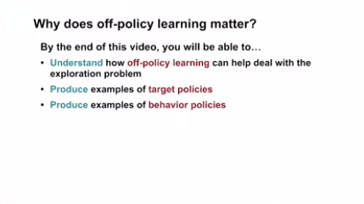
191. .
192. 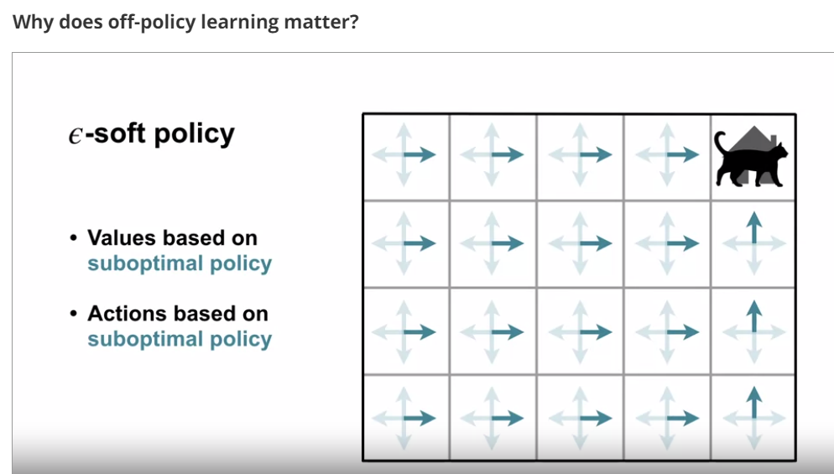
193. .
194. E-soft=policy is best for acting and learn both ,also explore best actions
195. .
196. 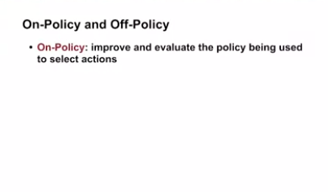
197. .
198. 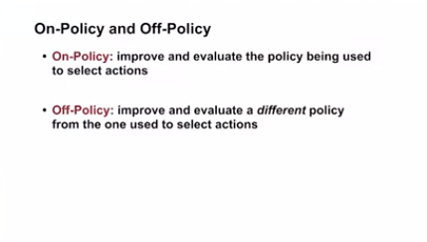
199. .
200. . **Off-policy = learning policy -x while following policy -y**
201. Lets say
202. Policy agent learning = Target Policy (pi)
203. .
204. 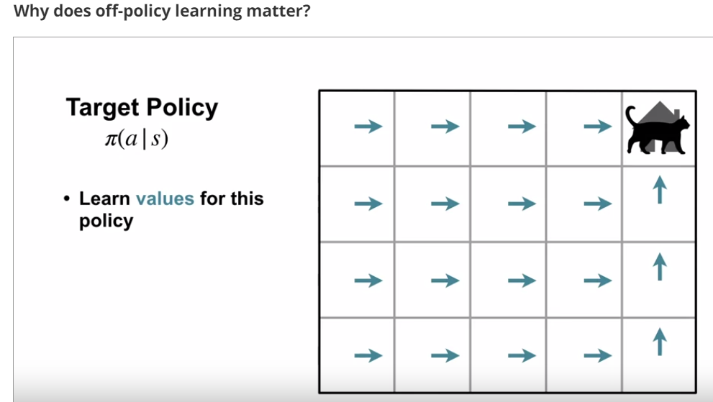
205. .
206. The Value function agent is learning is based on **Target policy**
207. .
208. 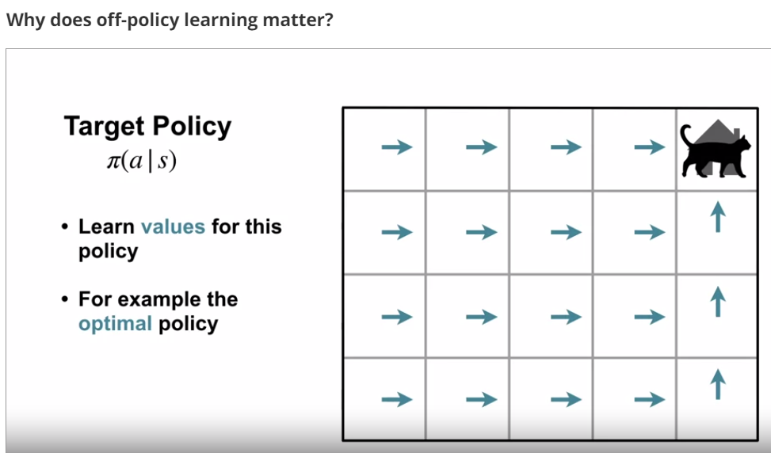
209. .
210. .
211. The policy, agent is using to select action we call as **Behavior policy**
212. **.**
213. **Dd**
214. **.**
215. 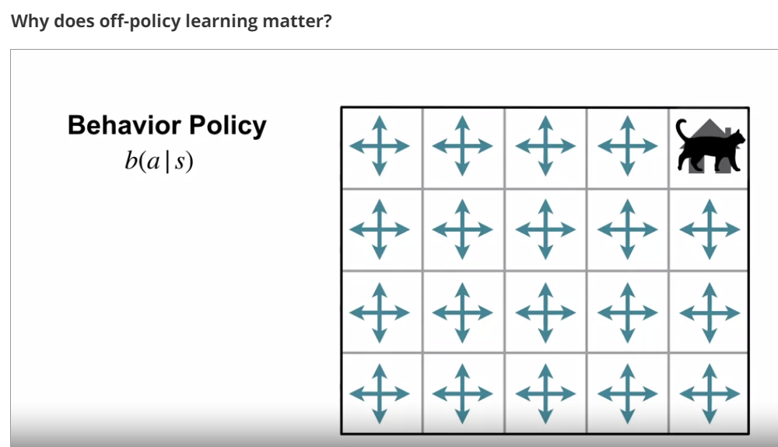
216. **.**
217. **.**
218. 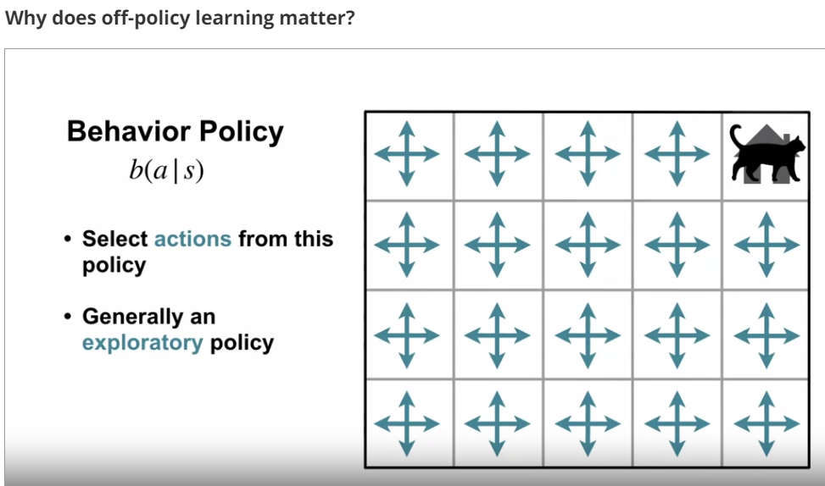
219. **.**
220. Why we are separating policy in to target and behavioural ???
221. .
222. **Sol**:this provides a solution for **continual exploration**
223. **.**
224. .
225. Point-1 : If Agent follows according to target policy ,then we may experience limited states explored
226. 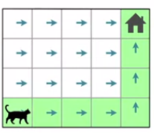
227. .
228. .
229. Point-2 : If Agent behaves according to policy that supports exploration, then we have more number of states explored
230. .
231. 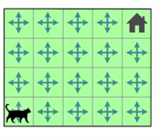
232. .
233. .
234. Off-policy some eg=xamples are a.paralell learning b.demonstration learning
235. .
236. .
237. Rule of off-policy learning = Behavioural policy must cover to target policy
238. .
239. 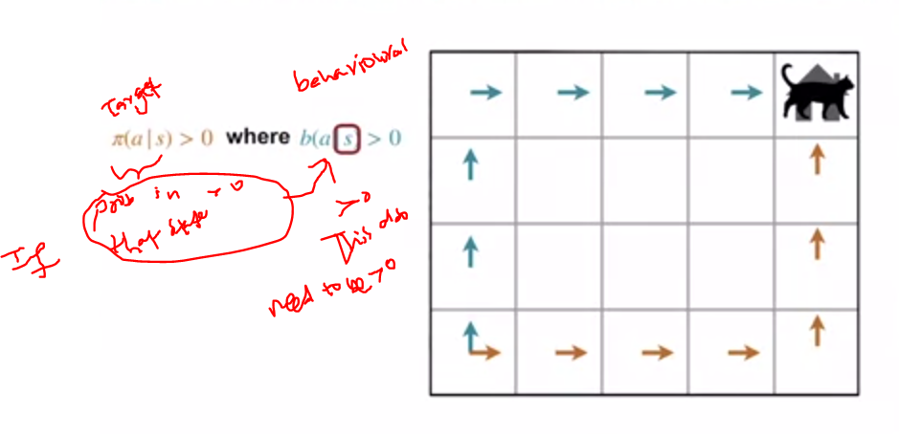
240. .
241. If in state s , probability >0 then in behavioural policy in that state s should have probability > 0
242. .
243. 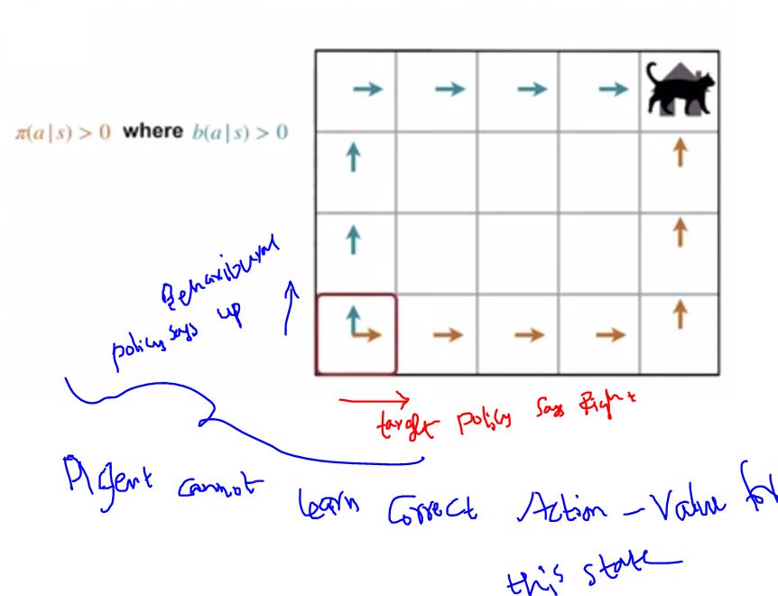
244. .
245. .
246. Why agent cant learn action value ,because agent never observe what would happen if it goes right.
247. .
248. 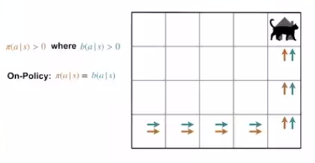
249. .
250. 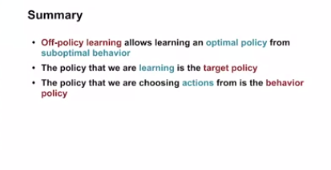
251. .Importance sampling helps us learn off-policy
252. .
253. **Off-policy = learning policy -x while following policy -y**
254. **.**
255. 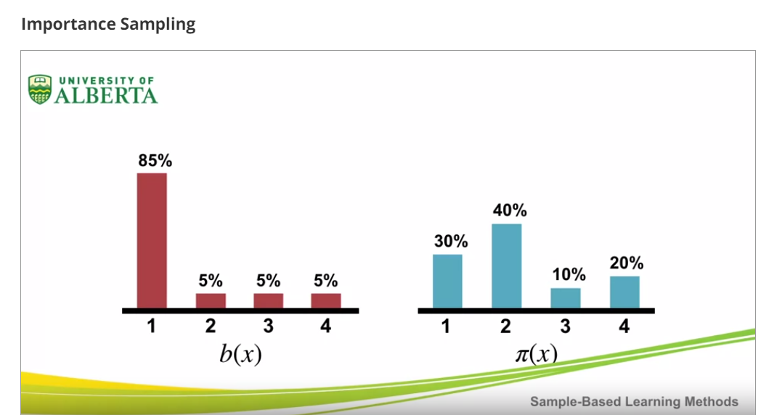
256. **.**
257. **.**
258. 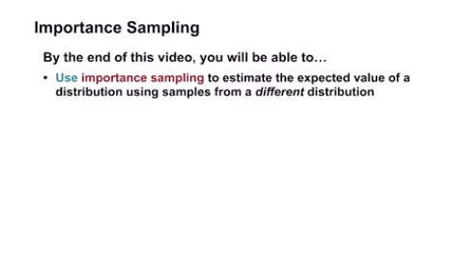
259. **.** 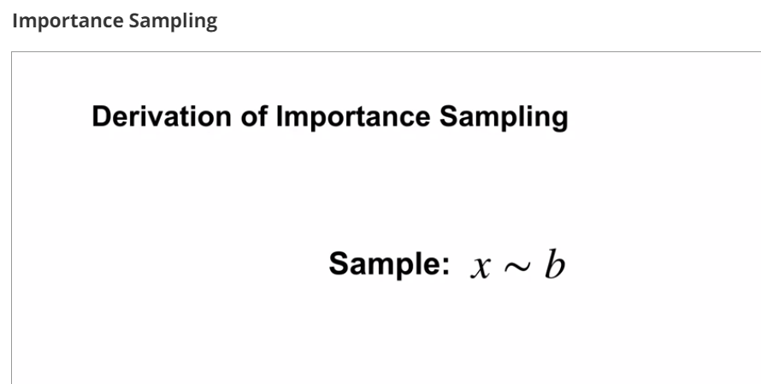
260. **.**Lets We have some random variable x that's being sampled from a **probability distribution b.**
261. **.**
262. **.**
263. 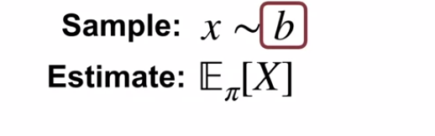
264. **.**
265. **Lets estimate.**
266. We want to estimate the **expected value of x** (E(x))but
267. with respect to the target distribution Pi.
268. Because x is drawn from b,
269. we cannot simply use
270. the sample average to compute the expectation under Pi.
271. This sample average will give us
272. the expected value under b instead.
273. **.**
274. **.**
275. 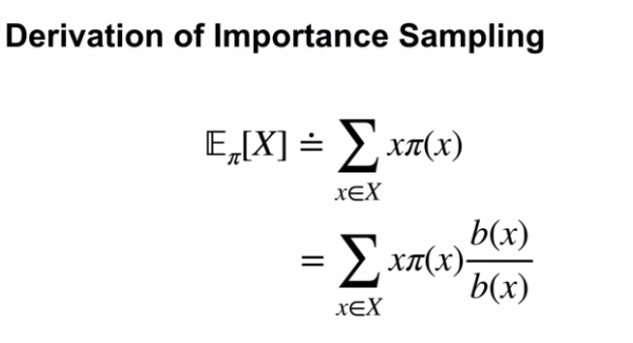
276. **.**
277.** 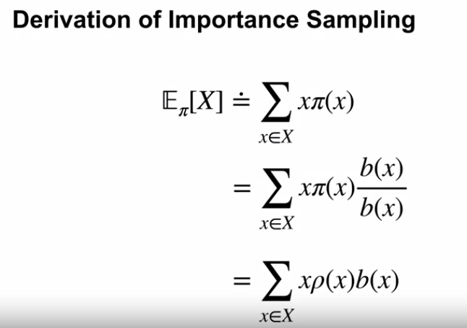.**
278. **.**
279. **.**
280. 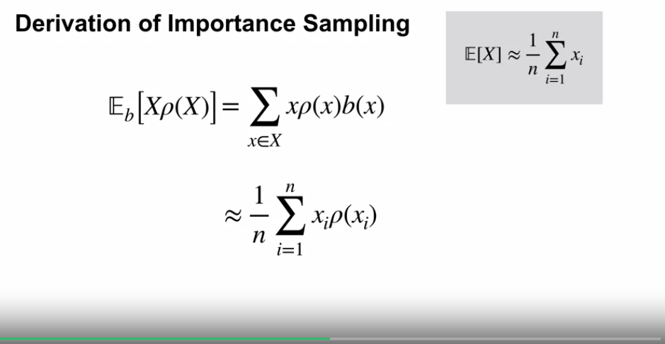
281. **.**
282. 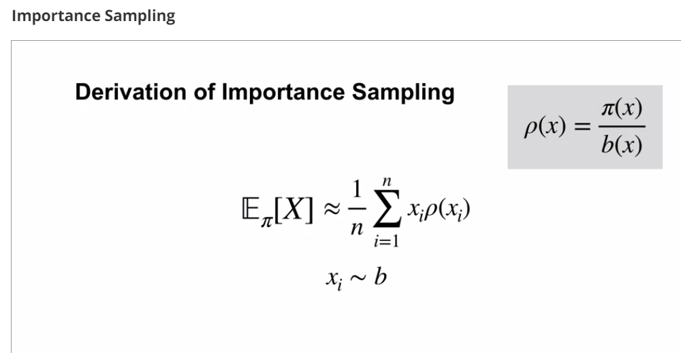
283. **.**
284. **.**
285. **.**
286. 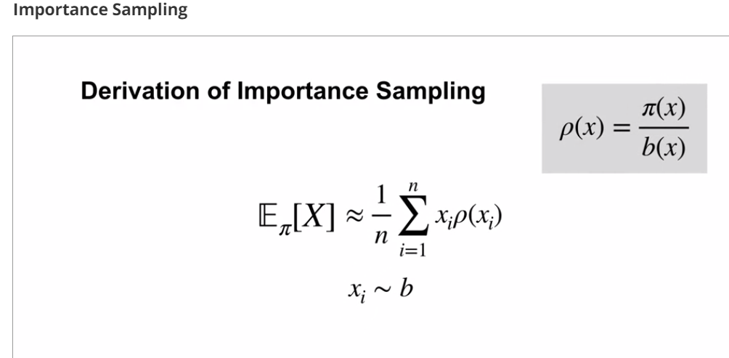
287. **.**
288. 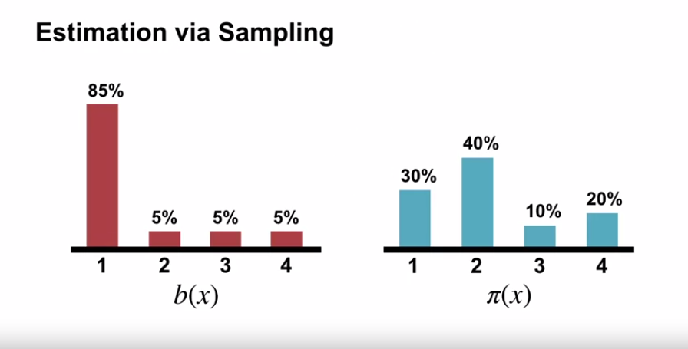
289. **.**
290. **Process :1.draw samples from according to b and 2.try to estimate expected value under PI**
291. **.**
292. 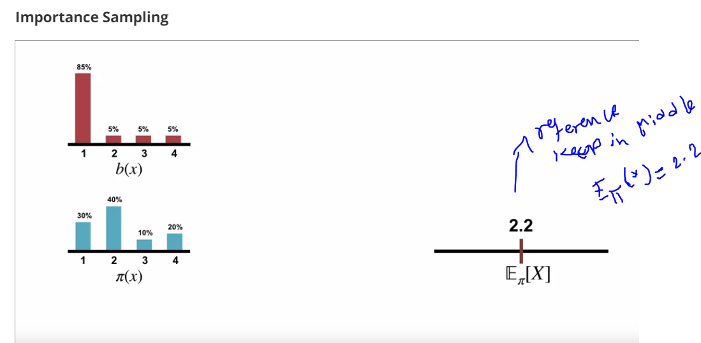
293. **.**
294. **.**
295. **Now lets draw a sample from b**
296. **.**
297. 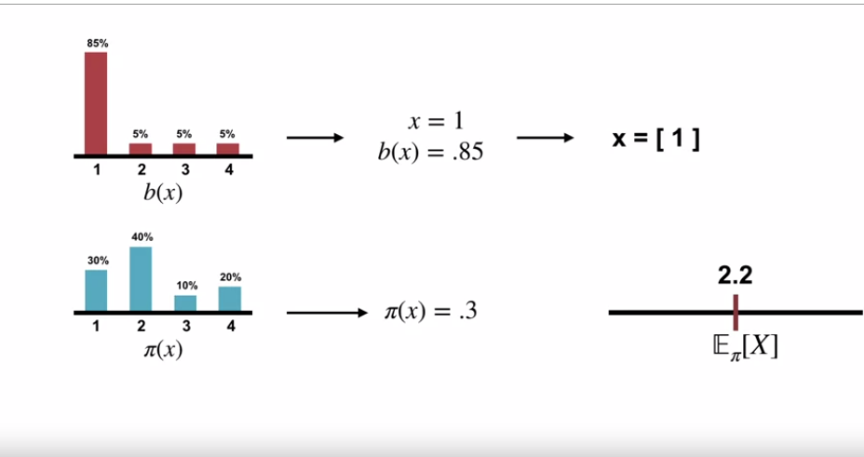
298. **.**
299. **.**
300. 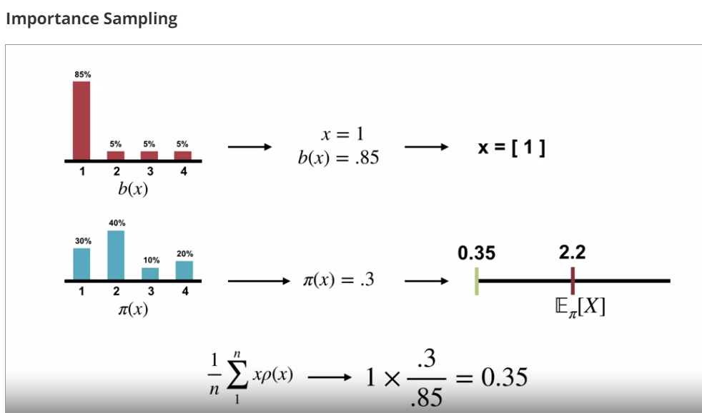
301. **.**
302. **.**
303. 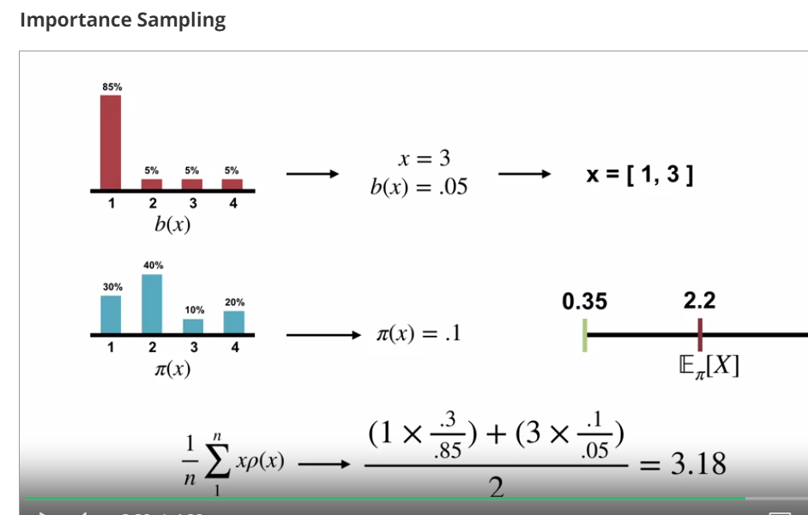
304. **.**
305. **.**
306. **.**
307. 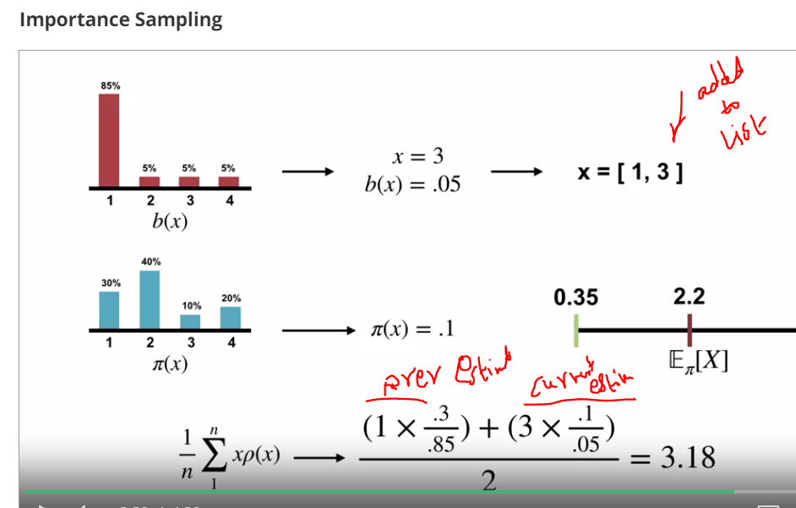
308. **.**
309. **.**
310. 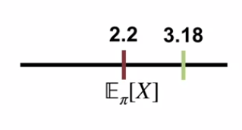
311. **.**
312. **.**
313. 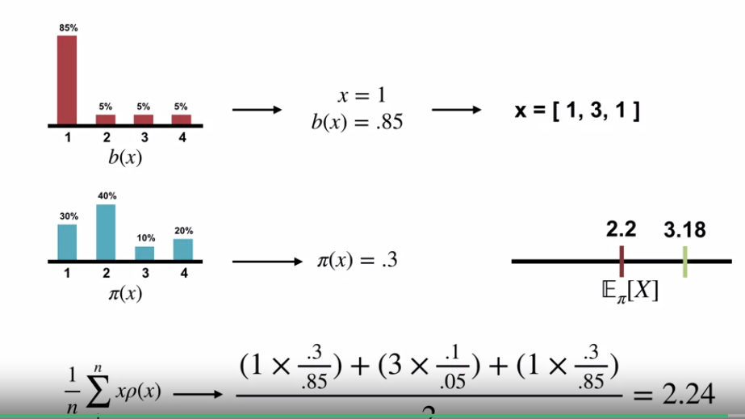
314. **.**
315. **..**
316. **.** 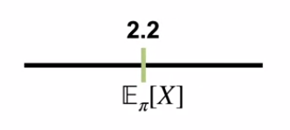
317. **.**
318. **.**
319. **.We managed to get Expectation under PI**
320. **.**
321. 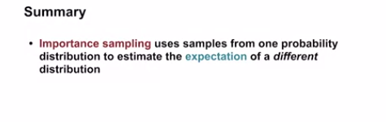
322. **.**
323. **.**